R. Gonzalez Management Inc., (RGM)
Student Financial Aid Services Phone No. (323) 730-8700
3560 S. La Cienega Blvd., Suite G Fax No. (323) 730-8701
Los Angeles, CA 90016-4400 Web Page http://www.rgmsms.com
RGM MEMO

DATE: January 28, 2016
TO: School Owners and Financial Aid Personnel
RE: Enrollment Reporting Roster and Error Codes
_______________________________________________________________
We recently added an enhancement to the Enrollment Reporting Roster and Enrollment Error Response report in the RGM System. Getting clean data accepted by NSLDS is critical as part of administrative capability.
A school employee with Administrator access can see the report by going to Administration>>>Data Management>>>ED Data Received>>> (0120) Enrollment Reporting Received.
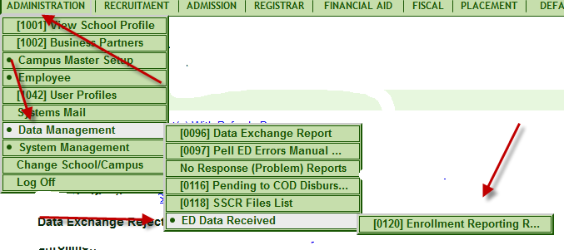

Once you are in the report options screen, you may select the Enrollment Reporting Roster or Enrollment Reporting Error Response, or the Old SSCR Roster or Old SSCR Error Response if you need to look back several years.
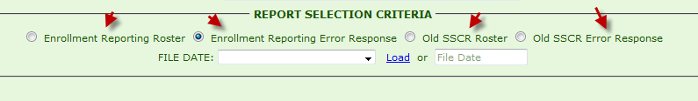
To check for any problems you need to fix, select the radio button next to Enrollment Reporting Error Response, then click on LOAD and wait for the file date list to fill in (most recent first). Sometimes this takes a few seconds. Do not click more than once on the LOAD link if it says processing please wait.
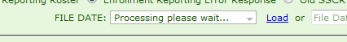
When the date appears, click GENERATE to populate the report.
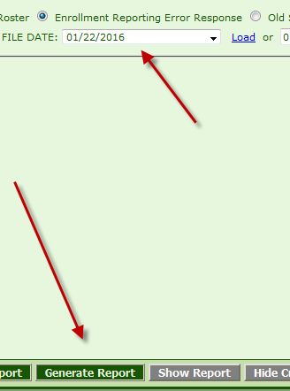
The generated report will have the all information indicated in the header below. The information will be separated into gray and green bars. The information on the gray bar contains the campus-level data, Birth Date, Cert. Date, Enrollment Effective date, Enrollment Status, Credential level, Anticipated Completion Date, Errors.
The information on the green bar contains the enrollment information such as CIP code, Length, Weeks in the Academic Year, Enrollment Effective date, Credential Level, Begin Date, Errors.
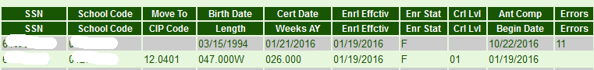
At the bottom of the report, there will be a summary of student counts and the errors listed.
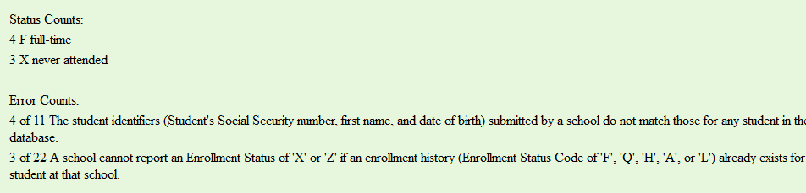
Errors 22, 26, 32 and 35 must be corrected by the school.
Errors 22 and 32 must be corrected in NSLDS.
Some examples of causes of error code 22 are below:
Now X, previously sent F with different start date. Now no enrollment with earlier date.
Now X, previously sent H with different start date. Now no enrollment with earlier date.
An example of error code 32 are below:
Can't tell what other data NSLDS has.

Please log in to NSLDS to correct these errors by following the instructions below.

First click on the Enroll Tab
Then go to Enrollment Update
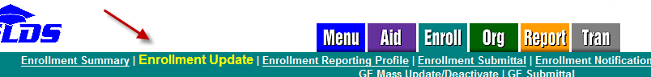
The screen below will populate. Select by Student or click Retrieve to show all records
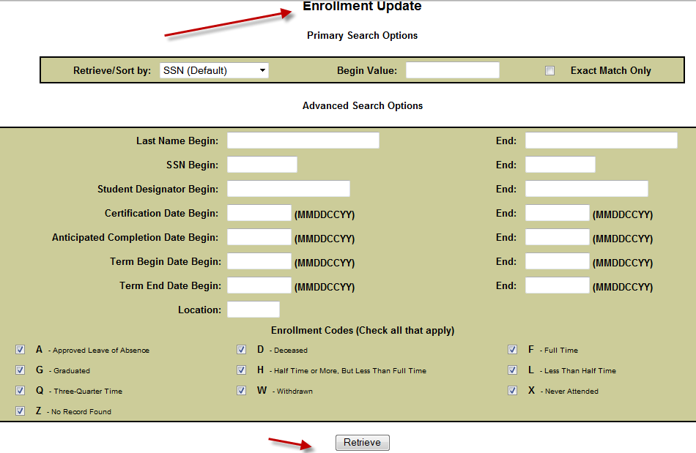
Look for the student name that had the specific error and correct the record.

Error codes 26 and 35 must be corrected in RGM
Error code 35 must be corrected by updating data in the RGM System.
Over 6 months since expected return from LOA.
Over 6 months since start of LOA (over 3 months since expected return).
Over 11 months since start of LOA (over 5 months since expected return).

Error 26 code must be corrected in RGM. It indicates bad, missing or late postings in attendance status, LOA returns, Student Ends, etc. Here are examples:
Bad attendance data. Nothing for months, then cumulative greater than enrolled.
No attendance data. Now 3+ months after expected end.
Missing attendance data. Nothing for months, then cumulative 4 hours short of enrolled, then nothing.
No attendance data. Now 12 months after expected end.
Completion hours posted, but termination not posted.
Missing Attendance Posting: 159 Student(s) With 14 Days or More Since Last Attendance Posting
Enrollment End: 42 Student(s) Still in School More Than 14 Days After Expected End

If you have any questions relating to this memo, please feel free to contact us.

Thank you,
Rafael

