R. Gonzalez Management Inc. (RGM)
Student Financial Aid Services Phone No. (323) 730-8700
3560 S. La Cienega Blvd. Suite G Fax No. (323) 730-8701
Los Angeles, CA 90016-4400 Web Page http://www.rgmsms.com

RGM Memo
Date: April 6, 2016
To: School Owners and Financial Aid Personnel
RE: Verification Process in the RGM system is now available for 2016-2017
On December 18, 2015 we sent out a Memo with our new system enhancement for the Verification process. We would like to inform you that it is now available for 2016-2017.

The screenshots below will help guide you on the steps for the process:

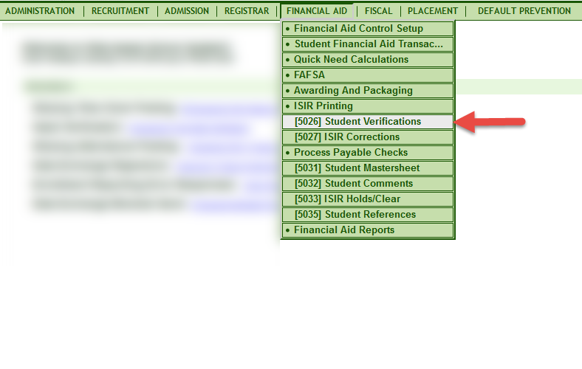

You select the award year and you can choose to view all students or a single student.

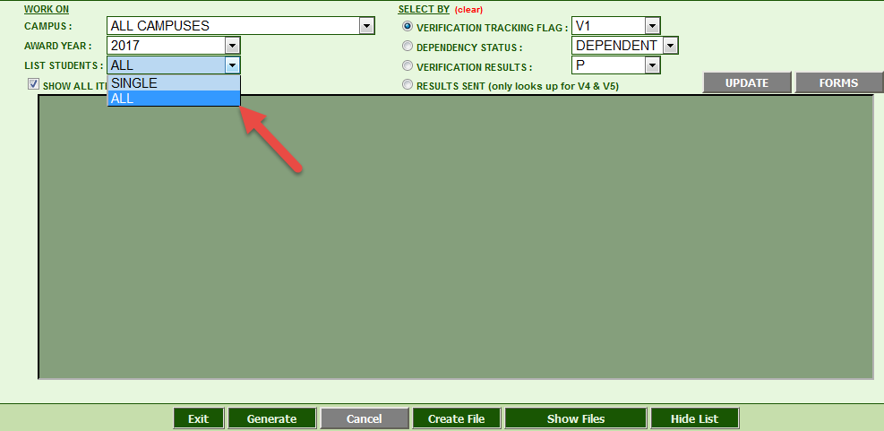

You can search by the type of Tracking Flag, Dependency Status or Verification Results, then you generate.

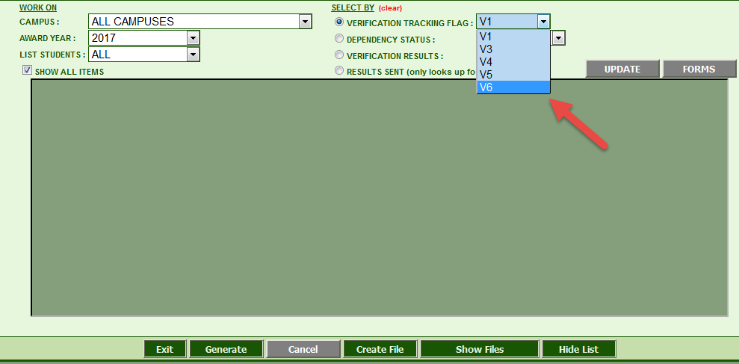

When you generate you will get the screen below: The report will only show you what you are required to verify for the type of tracking flag the student was selected for. You will then verify or correct each item on the list then update. The box where it says result, you will need to select one of the items from the list.

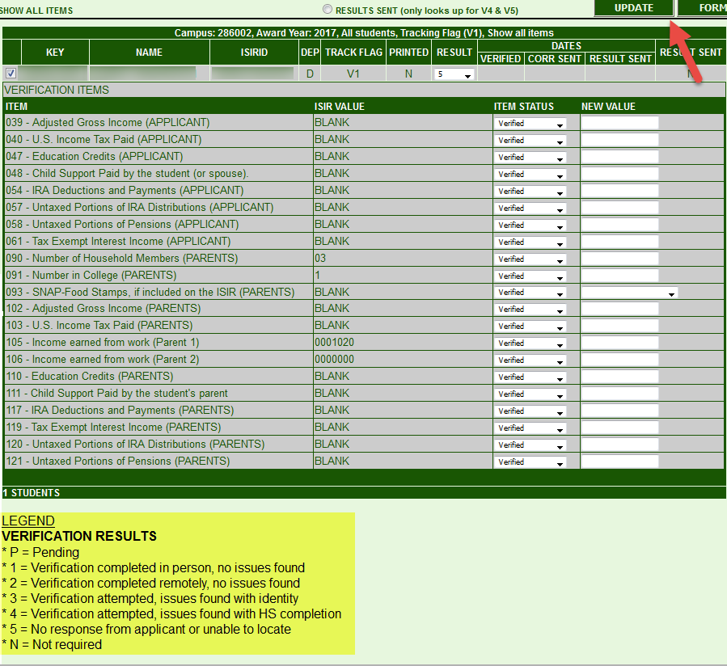

You will click on Forms once you are done verifying each item and you will get the Verification worksheet, it will only give you the pages for the tracking flag the student was selected for. On the bottom of the Worksheet you will have the option to print, open for entry or close.

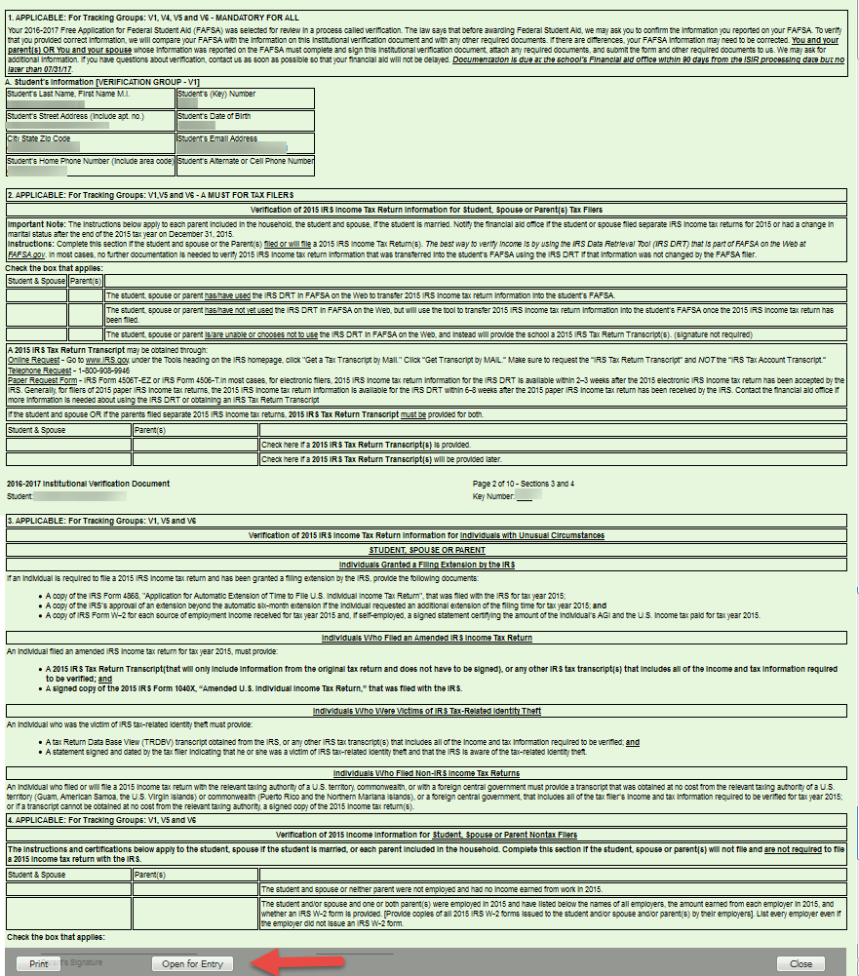

Open for Entry lets you type and check mark the fields for that tracking group.

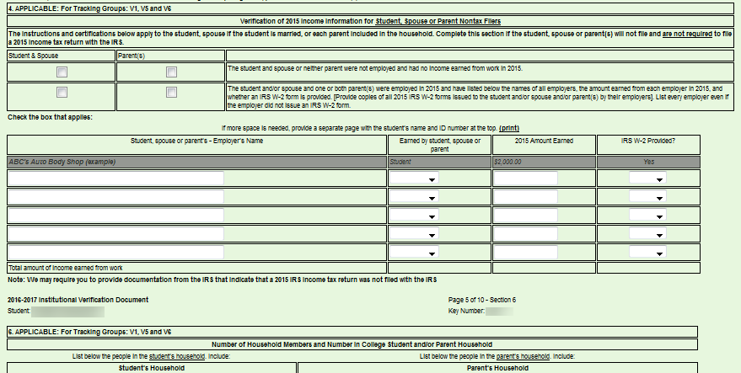

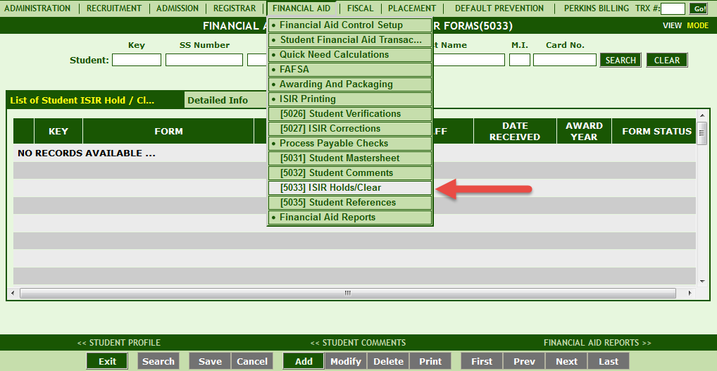

Lastly you will still need to clear the verification in transaction #5033, but we will be removing that step from the verification process and it should be ready in about 30 days.

