R. Gonzalez Management, Inc. (RGM)
Student Financial Aid Services Phone No. (323) 730-8700
3560 S. La Cienega Blvd., Suite G Fax No. (323) 730-8701
Los Angeles, CA 90016-4400 Web Page http://www.rgmsms.com
RGM MEMO

DATE: June 15, 2016
TO: School Owners and Financial Aid Personnel
RE: 2016 GE Reporting Due October 1, 2016
___________________________________________________________________

We will soon be processing GE Reporting for award year 2015-2016, which has a deadline of October 1, 2016.

2016 Award Year GE Reporting must be ACCEPTED by October 1, 2016. We will follow the same process as before by having your school administrator send us a form specifying whether or not we are to send the 2016 award year GE data for your school.

We will start sending 2016 data for your school in early September if you have authorized us to do so on the form.
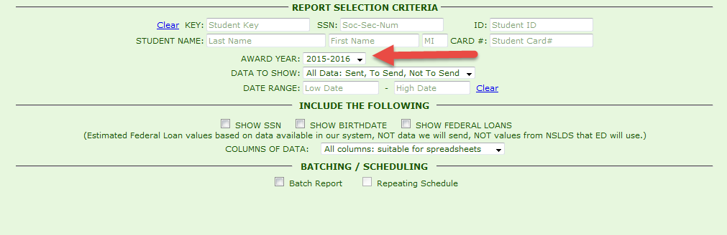

Sending the information one month prior to the October 1, 2016 acceptance deadline will give schools time to correct any errors that may come in from NSLDS.

It is important that you review any information on the report, especially your Institutional Debt, and work on the 2016 data as soon as possible.

Please return this form for 2016 award year GE Reporting as soon as possible to: Mayra Grijalva at mayra_grijalva@rgmsms.com or
Ana Paredes at ana_paredes@rgmsms.com or
Johanna Gonzalez johanna_gonzalez@rgmsms.com.
Once the form is received, the controls in the system will be opened for your school to send the data.

Thank you,
Rafael

Name of Institution______________________________________________

RGM School or Campus Number ___________________________________

Name, Title and Signature of Person submitting this form__________________________________________________________

I authorize RGM to submit Gainful Employment data via batch reporting for the 2016 award year which has an acceptance deadline of October 1, 2016.

Yes ______________

No ______________

Thank you.

