R. Gonzalez Management Inc. (RGM)
Student Financial Aid Services Phone No. (323) 730-8700
3560 S. La Cienega Blvd. Suite G Fax No. (323) 730-8701
Los Angeles, CA 90016-4400 Web Page http://www.rgmsms.com
RGM Memo
Date: November 4, 2016
To: Dear School Owners and Financial Aid Personnel,
RE: How to Print the MPN from the IFAP and COD website
Below you will find the steps on how to print the MPN and the Plain Language Disclosures from the IFAP and COD website.

IFAP website: https://ifap.ed.gov/ifap/processing/directLoans.jsp

Once you click on the link above and get to the IFAP website, you will click on the MPNs and Communications link on the right side:
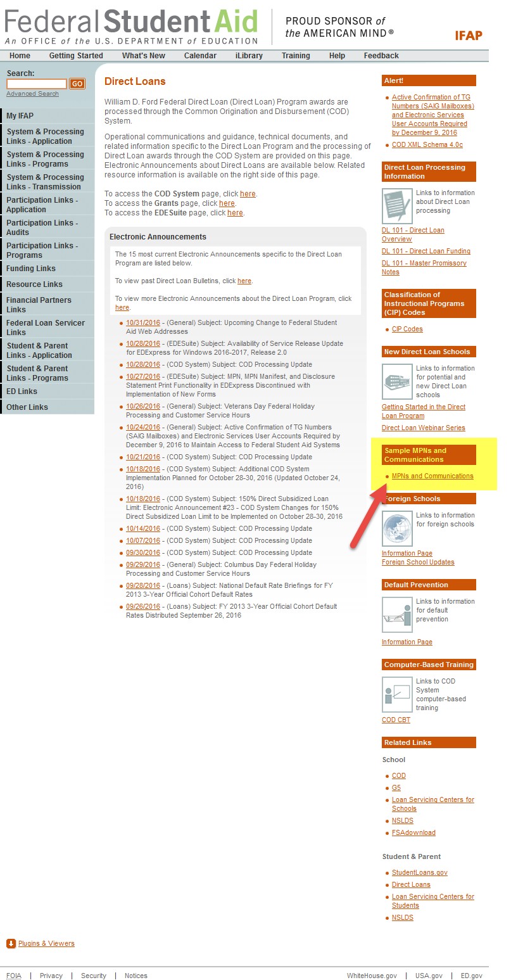

You will then get this page below, and you will then select one of the options below:
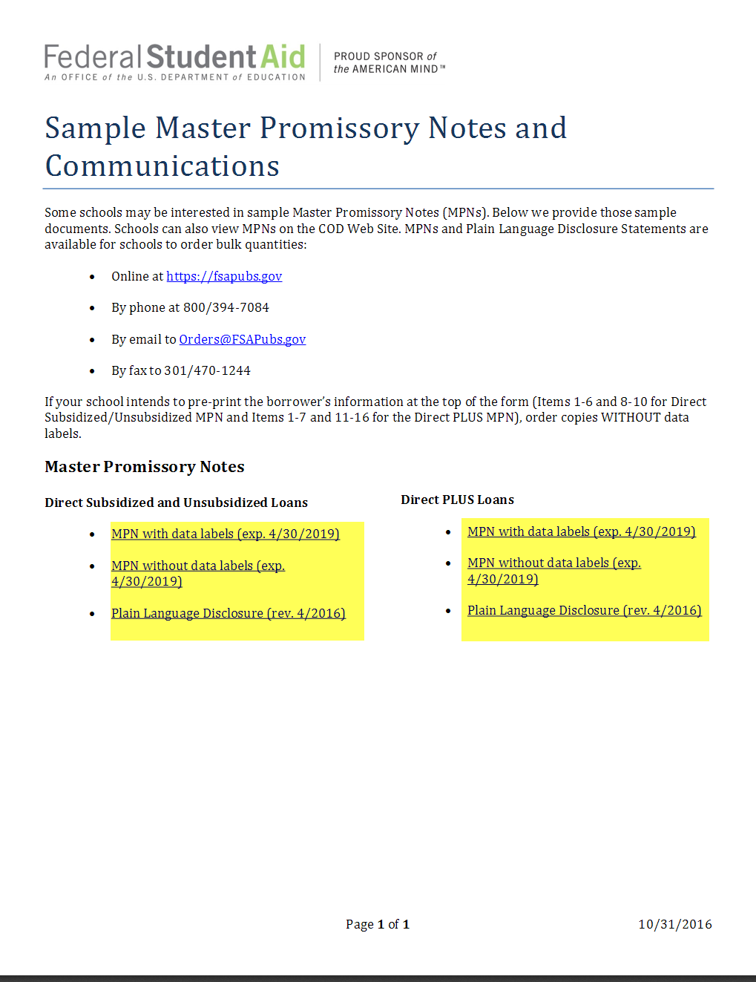

You will be able to fill in the fields:
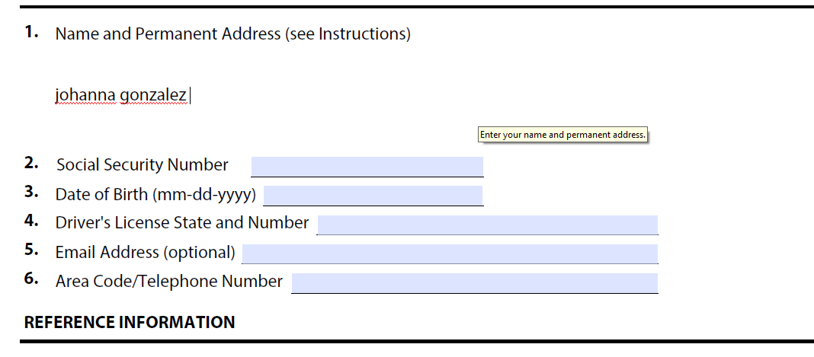

COD website: https://cod.ed.gov/cod/LoginPage

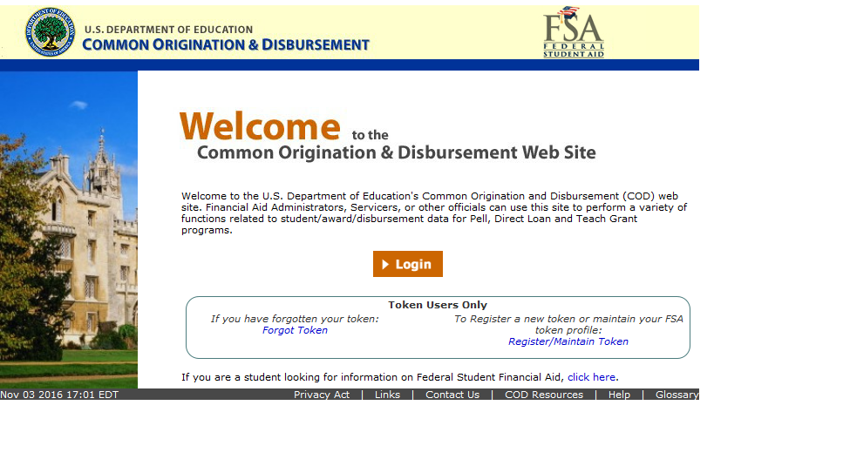

You then click on the services tab:

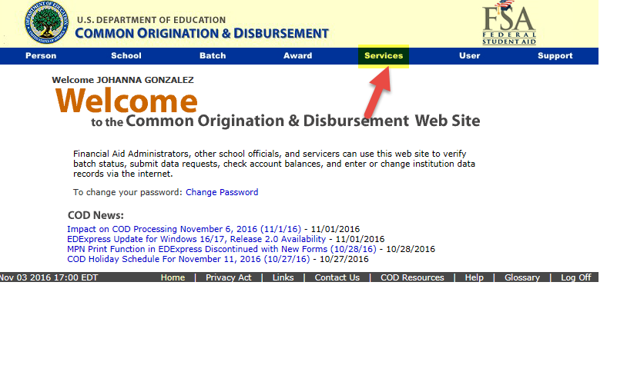
Then you will see the following screen and you will click on Downloads:
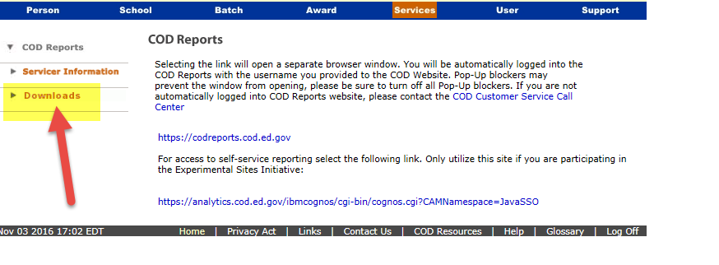
You will click on the blue link titled Subsidized/Unsubsidized or the Plus link:
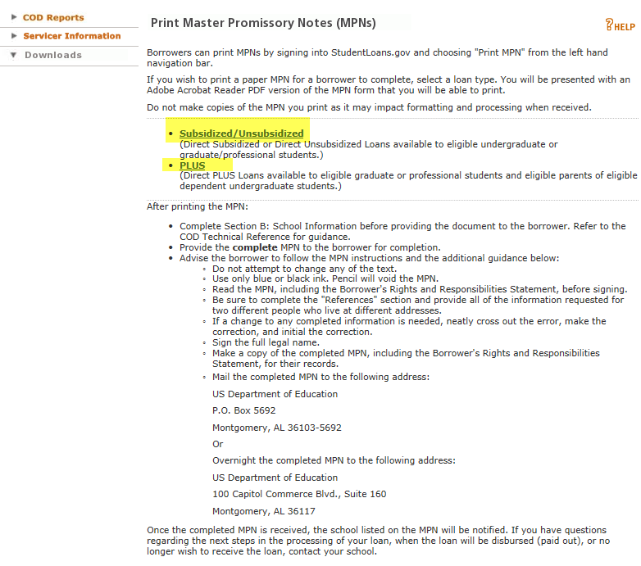

This is the sample of the MPN before you print, you will not be able to type on the MPN as you can on the MPN from the IFAP website:


