R. Gonzalez Management Inc. (RGM)
Student Financial Aid Services Phone No. (323) 730-8700
3560 S. La Cienega Blvd. Suite G Fax No. (323) 730-8701
Los Angeles, CA 90016-4400 Web Page http://www.rgmsms.com

RGM Memo
Date: March 10, 2017
To: School Owners and Financial Aid Personnel
RE: Verification Process in the RGM system is now available for 2017-2018
On December 18, 2015, we sent out a Memo with our new system enhancement for the Verification process for 2016-2017. We would like to inform you that it is now available for 2017-2018.

The screenshots below will help guide you on the steps for the process:

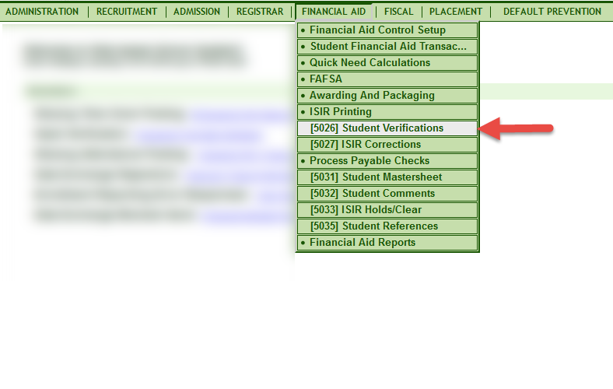

You select the award year and you can choose to view all students or a single student. For all students, you must select one option on the right side, you can search by Verification Tracking Flag, Dependency Status or by Verification Results. Then click generate:

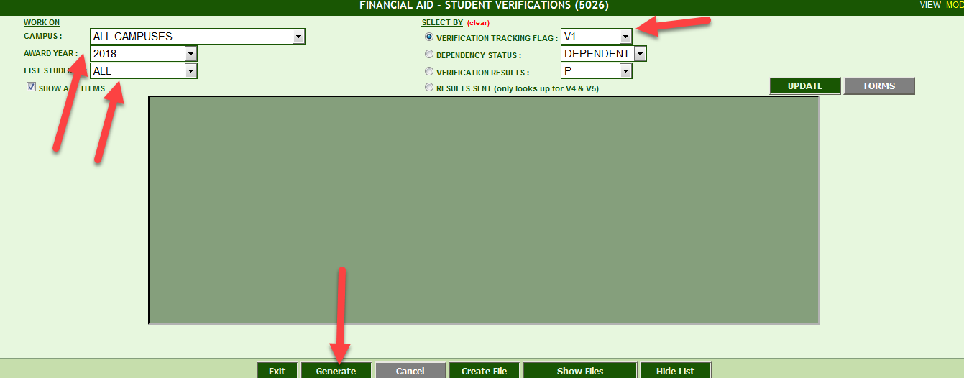

When you choose single instead of All, under List Students you enter single and you do not need to click anything on the right-hand side under Select by. You will need to enter a key number and click search. Then click generate and the student’s information will populate.
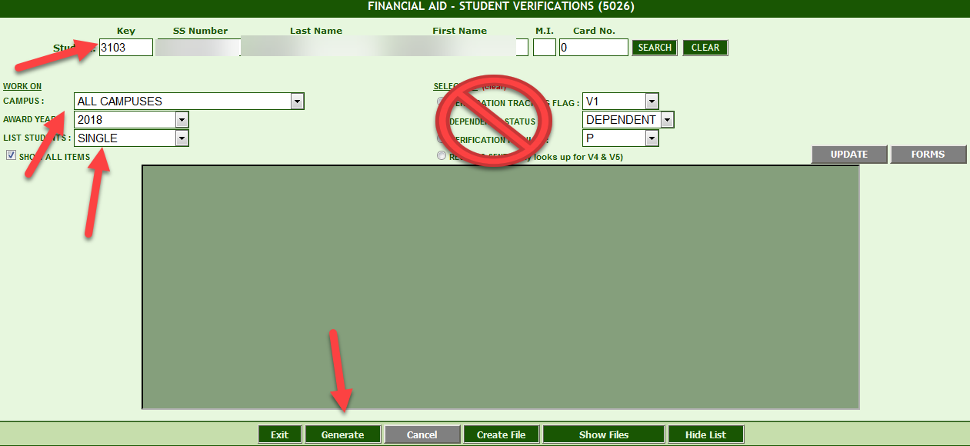

When you generate you will get the screen below: The report will only show you what you are required to verify for the type of tracking flag the student was selected for. You will then verify or correct each item on the list then update. The box where it says result, you will need to select one of the items from the list.

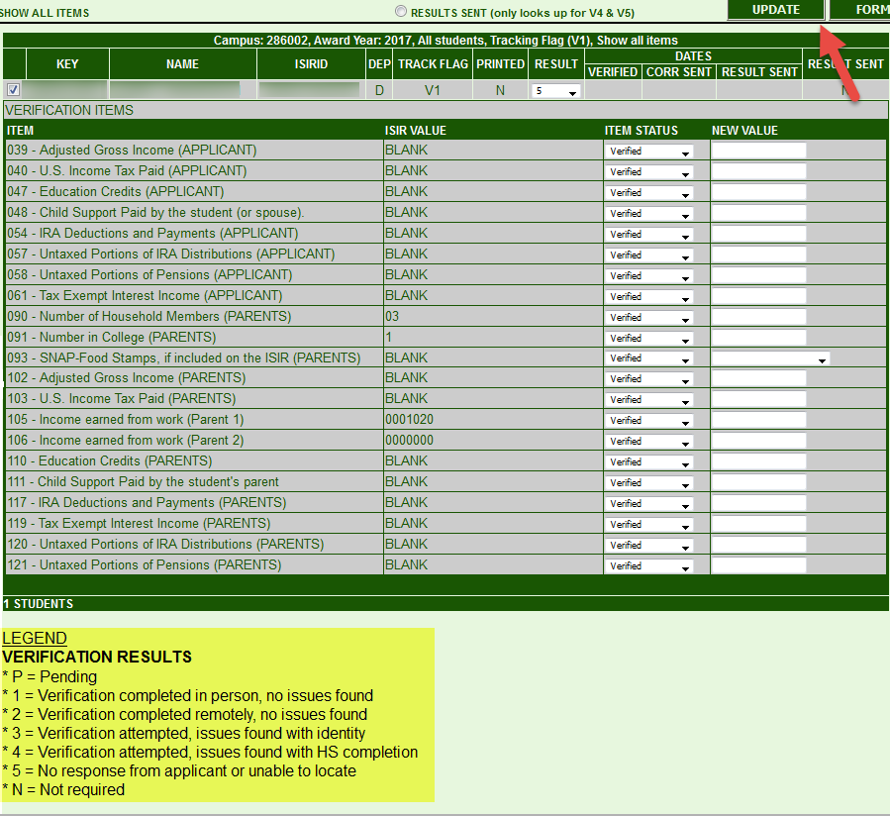

You will click on Forms once you are done verifying each item and you will get the Verification worksheet, it will only give you the pages for the tracking flag the student was selected for. On the bottom of the Worksheet you will have the option to print, open for entry or close.

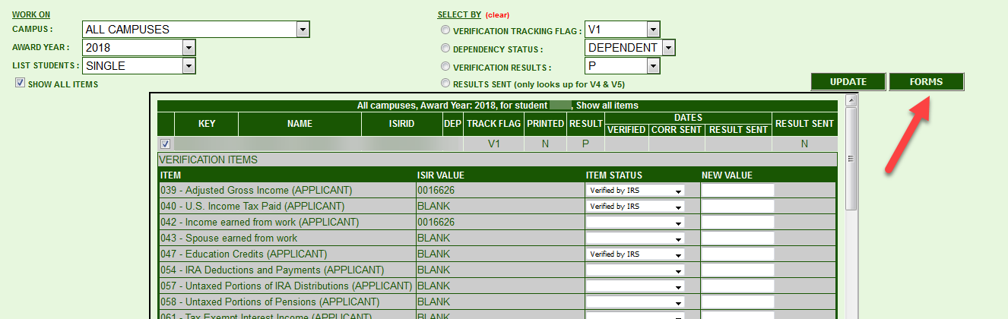

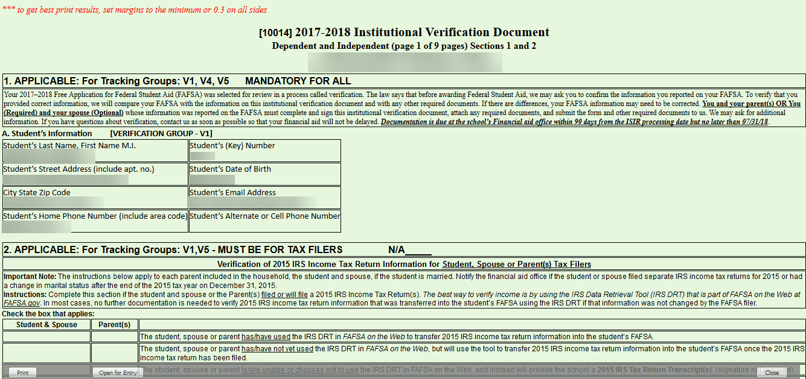

Open for Entry lets you type and check mark the fields for that tracking group.

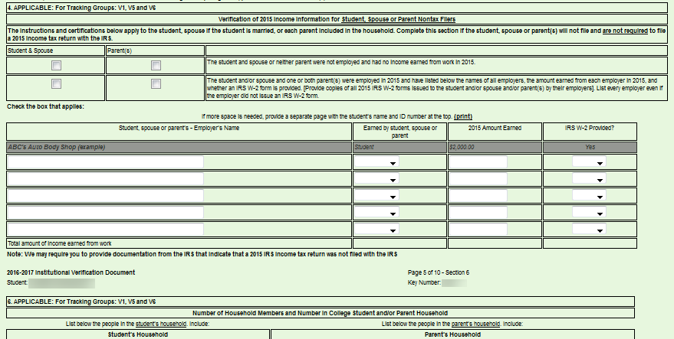

This step automatically clears the verification in transaction #5033:
