R. Gonzalez Management, Inc. (RGM)
Student Financial Aid Services Phone No. (323) 730-8700
3560 S. La Cienega Blvd., Suite G Fax No. (323) 730-8701
Los Angeles, CA 90016-4400 Web Page http://www.rgmsms.com
RGM MEMO

DATE: August 11, 2017
TO: School Owners and Financial Aid Personnel
RE: 2017 GE Reporting Due October 1, 2017
___________________________________________________________________
Dear School Owners and Financial Aid Personnel,

RGM MEMO AUGUST 11, 2017

An Electronic Announcement was posted on August 2, 2017, regarding the Gainful Employment Reporting Deadline date of October 1, 2017. Please note that this year October 1st falls on a Sunday, so the real deadline (the last batch RGM will send) is the morning of Friday, September 29. For the GE data to be valid please make sure that your reminders screen is cleaned up. Also it is important that you review any information on report [5525] Gainful Employment Reporting under the Financial aid menu, especially your Institutional Debt. Below you will see a list of those reminders. We have attached the instructions on how to generate the Gainful Employment Report and the form you must submit to us no later than September 1, 2017. Below we have included the link to the Electronic Announcement.

Reminders:
Refunds Due
Need Verification
Missing Attendance Posting
Enrollment End
Enrollment Reporting Error Responses
Student leaves

Please note that RGM will only be reporting for the 2016-2017 Award Year. Any revisions to previously reported prior year data must also be submitted by October 1, 2017, but you will do that directly in the NSLDS website.

Please copy and paste link to your browser:

https://ifap.ed.gov/eannouncements/080217GEEA107InfoGERptgbyOct1Deadline.html

If you have not already done so please return the form attached as soon as possible to any of the RGM staff members below:

Mayra Grijalva at mayra_grijalva@rgmsms.com
Johanna Gonzalez at johanna_gonzalez@rgmsms.com

Rafael Gonzalez
President
R. Gonzalez Management, Inc.
3560 S. La Cienega Blvd. Ste. G
Los Angeles, CA 90016
(323)730-8700 ext. 239
(323)730-8701 fax

We will soon be processing GE Reporting for award year 2016-2017, which has a deadline of October 1, 2017.

2017 Award Year GE Reporting must be ACCEPTED by October 1, 2017. We will follow the same process as before by having your school administrator send us a form specifying whether we are to send the 2017 award year GE data for your school.

We will start sending 2017 data for your school in early September if you have sent us the form authorizing us to do so.
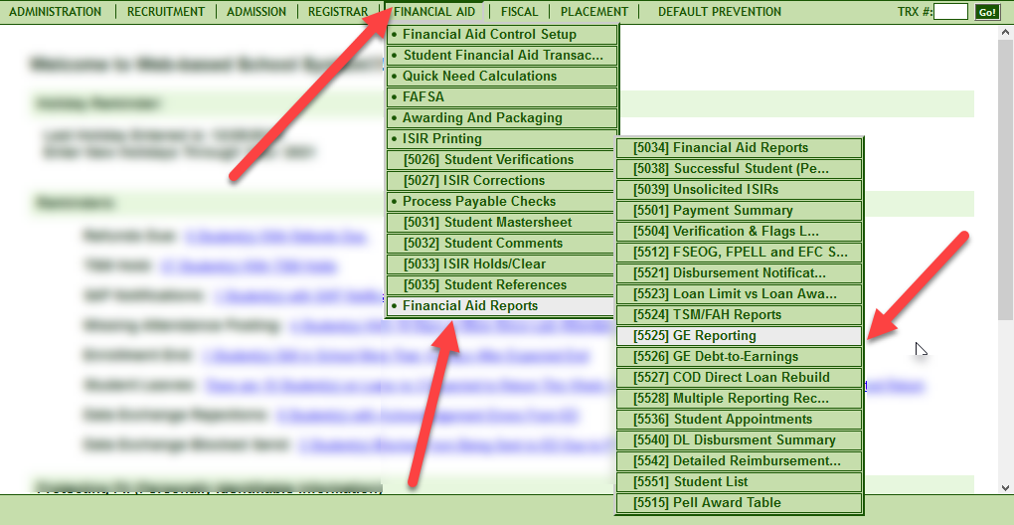

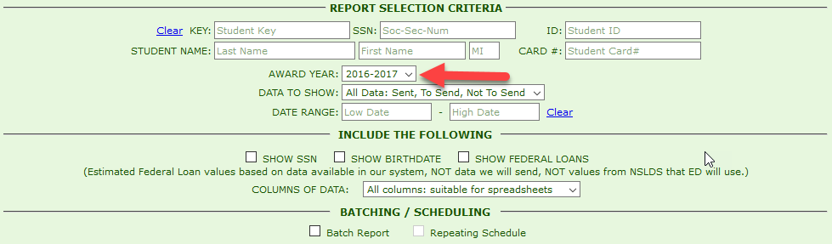
Sending the information one month prior to the October 1, 2017 acceptance deadline will give schools time to correct any errors that may come in from NSLDS.

It is important that you review any information on the report, especially your Institutional Debt, and work on the 2017 data as soon as possible.

Please return this form for 2017 award year GE Reporting as soon as possible to:

Mayra Grijalva at mayra_grijalva@rgmsms.com or
Johanna Gonzalez johanna_gonzalez@rgmsms.com.

Once the form is received, the controls in the system will be opened to send the data for your school.

Thank you,
Rafael

Name of Institution______________________________________________

RGM School or Campus Number ___________________________________

Name, Title and Signature of Person submitting this form__________________________________________________________

I authorize RGM to submit Gainful Employment data via batch reporting for the 2017 award year which has an acceptance deadline of October 1, 2017.

Yes ______________

No ______________

Thank you.

