**R. Gonzalez Management Inc. (RGM)**

Student Financial Aid Services Phone No. (323) 730-8700

3560 S. La Cienega Blvd. Suite G Fax No. (323) 730-8701

Los Angeles, CA 90016-4400 Web Page <http://www.rgmsms.com>

**RGM Memo**

Date: January 22, 2018

To: Dear School Owners and Financial Aid Personnel,

RE: Gainful Employment- Release of the 2018 GE Disclosure Template

Dear School Owners and Financial Aid Personnel,

RGM MEMO JANUARY 22, 2018

An Electronic Announcement was posted January 19, 2018, announcing the release of the 2018 GE Disclosure Template. The institutions will have until April 6, 2018 to update disclosures for each of their Gainful Employment (GE) programs, using the 2018 GE Disclosure Template. There were a few modifications, please refer to link below for the list. Under the GE regulations, institutions must provide warnings for programs that could become ineligible for Title IV based on the next round of final D/E rates. Loss of eligibility results after receiving overall “fail” ratings in any two (2) out of three (3) consecutive award years for which rates are calculated or after receiving combination of “fail” and “zone” ratings for four (4) consecutive award years for which rates were calculated. As a reminder for institutions that notified the Department that an alternative earnings appeal would be submitted for one or more GE programs, the deadline to submit an alternate earnings appeal is February 1, 2018. Below we have included the link to the Electronic Announcement.

**The Electronic Announcement has a link that isn’t working when you click on it, we have included the link for you below:**

<https://www2.ed.gov/policy/highered/reg/hearulemaking/2009/negreg-summerfall.html>

The link below takes you directly to the template page:

<https://ope.ed.gov/GainfulEmployment/>

Please copy and paste link to your browser:

<https://ifap.ed.gov/eannouncements/011918GEAnnounce110Rel2018GEDisclosureTemplate.html>

Our  report 1070 for GE Disclosures is written to show data for every Title IV eligible program that is either still active or has any enrollments in the report periods.

If the report is listing programs that you no longer offer and showing counts of zero, check the ACTIVE RECORD flag for the program (course or major).

Note that there are options for how to determine Expected End Dates, and therefore on-time completions. Which option works best depends on how your school posts data.

In our report #1070 for GE Disclosures, each count or other number based on an underlying list of students is shown in the report with a hidden table with the underlying list of students. Click the + on the left to show the hidden table on the screen or click the Print Preview link on the right to bring up a print preview window with the table.

When you use the Print Preview button at the bottom of the report screen, the preview will have each table showing or hidden to match the current state of your screen. We have included an attachment with screenshots to help guide you. Please do not use the old report under Administration, Campus Master Setup, Annual Reports, Annual Reports.

**Rafael Gonzalez**

**President**

**R. Gonzalez Management, Inc.**

**3560 S. La Cienega Blvd. Ste. G**

**Los Angeles,  CA 90016**

**(323)730-8700 ext. 239**

**(323)730-8701 fax**

Description: Description: cid:image001.jpg@01CE1597.4CBCA700

**CONFIDENTIALITY NOTICE**: The information contained in this email and any document attached hereto is intended only for the named recipient(s). It is the property of **R. Gonzalez Management, Inc.** and  shall not be used, disclosed or reproduced without the express written consent of **R. Gonzalez Management, Inc.**. If you are not the intended recipient or the employee or agent responsible for delivering this message in confidence to the intended recipient(s), you are hereby notified that you have received this transmittal in error, and any review, dissemination, distribution or copying of this email or its attachments is  strictly prohibited. If you have received this email in error, please notify the sender immediately by return email or by calling (**323) 730-8700**, and delete the material from any computer.

Institutions must update their Gainful Employment Disclosures Templates for the 2018 year no later than April 6, 2018.

The department requires the institution to use their GEDT template then upload the Gainful Employment Disclosure page which is generated by the template onto the institution’s website. Gainful Employment Disclosures Template updates must be done for each GE programs using the 2018 GE Disclosure Templates. The completion rate calculated on the 2018 template is based on the most recent cohort of students for whom sufficient time has passed for the cohort to complete the program within its scheduled length.

The Gainful Employment Disclosures Template Quick Start Guide takes users through basic step by step instructions on how to use the template along with sample pictures of each screen you will see under each step. We recommend you read the quick start guide to get familiar with the process. By reading the guide you will also know what information you will need to complete each step.

Please copy and paste the following link onto your browser for the 2018 GE Disclosure Template web page:

<https://www2.ed.gov/policy/highered/reg/hearulemaking/2009/negreg-summerfall.html>

The link below takes you directly to the template page:

<https://ope.ed.gov/GainfulEmployment/>

The RGM system has a report under Administration that contains the information you will need to fill out the template. The dates are already defaulted to 2018 Year.

Select Administration: Campus Master Setup: Annual Reports: [1070] GE Disclosures Report:

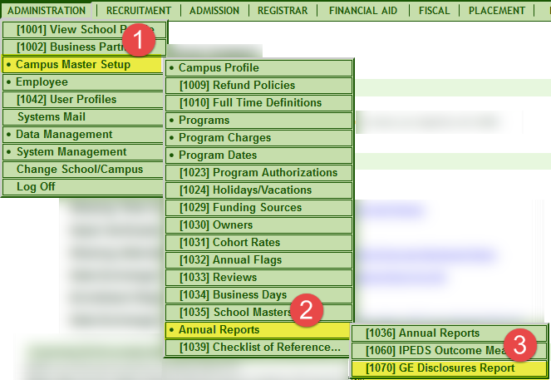

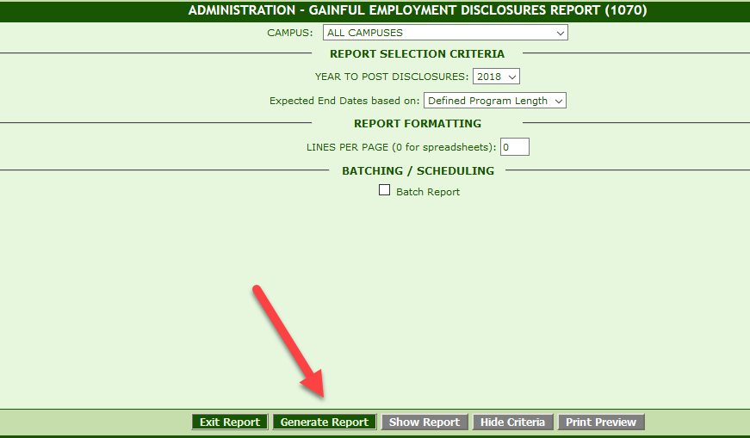

The lists of students are available if you click on the + next to the title, e.g. “Title IV students started 07/01/2015-06/30/2016”:

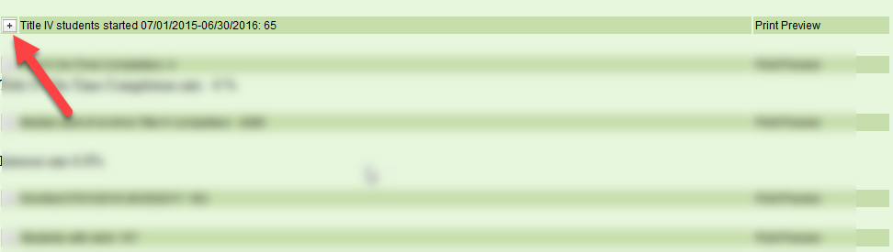

You will get a list like the sample below:

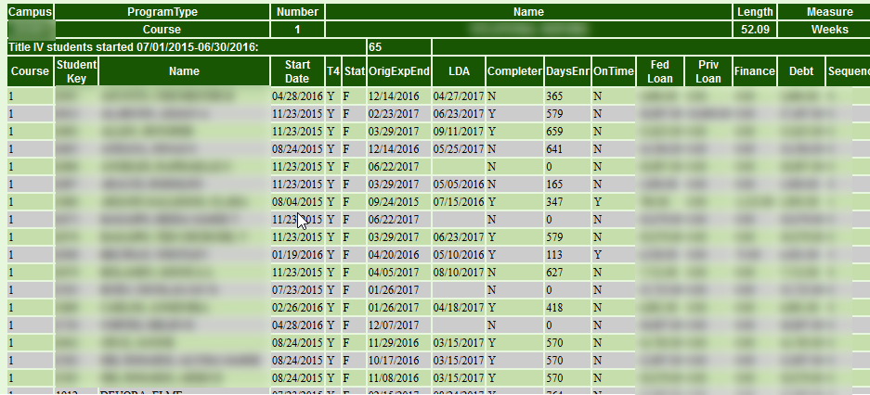

There is also a Help desk you can call if you have problems filling out the template

(855) 359-3697 or email them at [gedt@inovas.net](mailto:gedt@inovas.net)

Thank you,

Rafael