R. Gonzalez Management Inc. (RGM)
Student Financial Aid Services Phone No. (323) 730-8700
3560 S. La Cienega Blvd. Suite G Fax No. (323) 730-8701
Los Angeles, CA 90016-4400 Web Page http://www.rgmsms.com
RGM Memo
Date: January 16, 2018
To: School Owners and Financial Aid Personnel,
RE: Books and Supplies
Dear School Owners and Financial Aid Personnel,

RGM MEMO JANUARY 16, 2018

VERY IMPORTANT

We recently had a comment from one of our client’s CPA regarding the books and supplies charges. His comment was that schools must prorate the charges for books and supplies throughout the whole program. We are aware that many of you charge for books and supplies on the 1st payment period, however, the USDE is interpreting this change with the July 1, 2016, regulations. The 16/17 as well as the 17/18 Handbook says the opposite of the interpretation, but the USDE is working to update the Handbook. If you paid a student with 17/18 funds for the 1st payment period before July 1, 2017, this regulation interpretation applies to those students. The reason why the proration should be done throughout the program and not just in the 1st payment period is because the students do not have a real and reasonable opportunity to purchase the books, supplies and equipment elsewhere. We did our research and asked the Department of Education for clarification on this concern. The answer from the Department of Education and what we found seems to point to the direction that the correct way to charge the books and supplies is to prorate them throughout the whole program. Below we have included both the answer and what we found.

We are working on changes to our system to handle this change in ED requirements. We hope to have our changes done by February 1, 2018. We hope to be able to apply the change only to enrollments after implementation, but will make changes retroactive if the Department of Education publishes a Dear Colleague Letter specifying a retroactive start date.

Department of Education:
The Preamble discussion notes that prorating charges for books, supplies, and equipment is only required if those charges are included as part of tuition and fees and the institution charges the student up front for an amount of tuition and fees that exceeds the amount associated with the payment period. An institution must include the cost of books, supplies and equipment as part of tuition and fees under 34 CFR 668.164 (c)(1)(i) if a student does not have a real and reasonable opportunity to purchase the books, supplies, and equipment elsewhere. This is true even if the institution charges for the books and supplies as a separate line item on the student’s ledger account or expresses the charge separately in the student’s enrollment agreement. Note that Title IV aid may be credited for all charges described under (c)(1)(i) without student authorization if the institution follows the stipulations about charging below market rates, book/equipment availability, or health and safety etc. described in 34 CFR 668.164(c)(2).
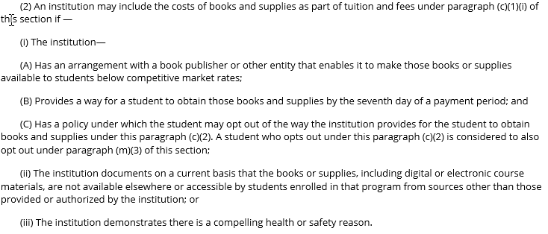
The books/supplies/equipment charge is either defined under 34 CFR 668.164(c)(1)(i), which makes it necessarily an institutional charge, or it is not. If it is not an institutional charge, then (c)(1)(ii) applies, and crediting Title IV aid to pay for the charge requires a student/parent authorization. Note that in (c)(1)(ii) we reference “The amount incurred,” not charged, the understanding being that the student was not automatically charged for the books, supplies, and equipment but rather chose to purchase from the school thus incurring the amount. Books, supplies, and equipment that are institutional charges are included as part of tuition and fees per (c)(1)(i). 34 CFR 668.164(c)(5) provides the formula for determining prorated charges, instructing that for programs with substantially equal payment periods, total institutional charges (inclusive of any book, supply or equipment charge defined under (c)(1)(i)) be divided by the number of payment periods (for other programs, the institution must divide the number of credit or clock hours in the payment period by the number of hours in the program and multiply the result by total institutional charges for the program).

The determining factor in whether the proration requirement applies is whether or not the charge for books, supplies and equipment is an institutional charge. If the charge is part of an enrollment agreement or any addendum, and/or the institution routinely debits the students ledger account for the amount of the charge along with tuition and fees, it is an institutional charge considered to be part of tuition and fees. Also, as noted above, if the student has no real and reasonable opportunity to purchase these items elsewhere, it is an institutional charge.

RGM’s research:

This is a 17-18 Handbook p. 5-16 sidebar which was NOT in the 16-17 Handbook:
Apportioning and prorating charges
The October 30, 2015 cash management regulations for apportioning and prorating charges must be followed when determining the amount of Title IV assistance retained for institutional charges as of the student’s withdrawal date. See Volume 4.
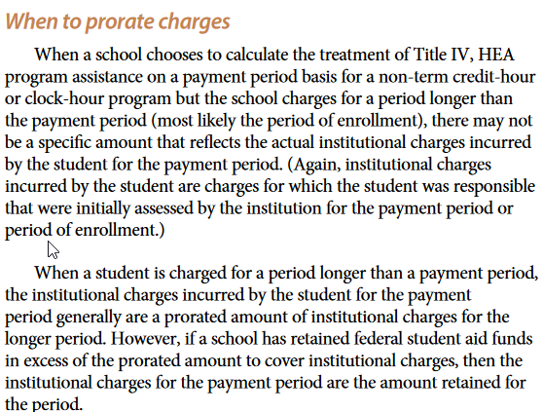
. 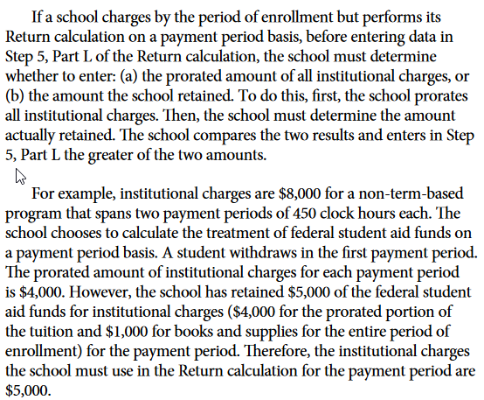

Department of Education:
R2T4 regulations found at 34 CFR 668.22(g)(3) require that if an institution charges for a period that is longer than the payment period, total institutional charges incurred by the student for the payment period is the greater of – the prorated amount of institutional charges incurred for the longer period; or the amount of Title IV assistance retained for institutional charges as of the student’s withdrawal date. Under the new cash management rules it is no longer possible for a school to retain more than the prorated amount of institutional charges.
RGM’s research:

This is still in the R2T4 section of the Handbook:
Returning equipment
If a school can substantiate that its return policies are reasonable,
consistent, and fair to all students, and students are notified in writing of
those policies when they enroll, the school may exclude documented costs
for nonreturnable equipment and returnable equipment if not returned
in good condition within 20 days of withdrawal. A policy that classifies all
used books or equipment as nonreturnable is not reasonable or fair. An
acceptable policy must specify the circumstances that would prevent the
school from selling the books or equipment to other students.

Thank You,

Rafael

