**R. Gonzalez Management Inc. (RGM)**

Student Financial Aid Services Phone No. (323) 730-8700

3560 S. La Cienega Blvd. Suite G Fax No. (323) 730-8701

Los Angeles, CA 90016-4400 Web Page <http://www.rgmsms.com>

**RGM Memo**

Date: April 9, 2018

To: School Owners and Financial Aid Personnel,

RE: 2nd Reminder on IPEDS Spring Report Due

Dear School Administrators,

RGM MEMO APRIL 09, 2018

IPEDS Spring reports are open, which include Human Resource, Academic Libraries, Fall Enrollment and Finance.

**The deadline is April 11, 2018!**

The only report generated from RGM is the Fall Enrollment which is available in: ***Administration/Campus Master Setup /Annual Reports/Trx 1036.***

The Finance Report is not generated from RGM, as it is based off your most recent audited financial statement, and often entered by that CPA.

***Tips:***

* If your school is considered a ***Program Reporter*** (IPEDS cohort date is for Fall Cohort) then select the ***IPEDS FALL ENROLLMENT REPORT-SPRING (PROGRAM REPORTER)*** version.
* Ensure the dates are defaulted to the same date range in the IPEDS system.
* If you base your student’s scheduled end dates on the student weekly schedules, then there is no need to change the “Determine Full Time based on” dropdown. If you base scheduled end dates on the enrollment status selected by the school under 3013, change the selection.

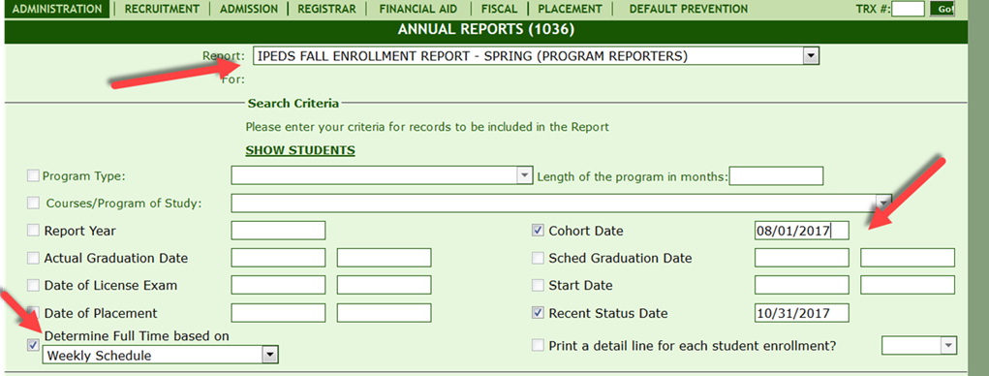

* **If your institution offers term programs, AND IPEDS is asking for a 10/15/17 cohort only, then select the *Academic Reporter version.***

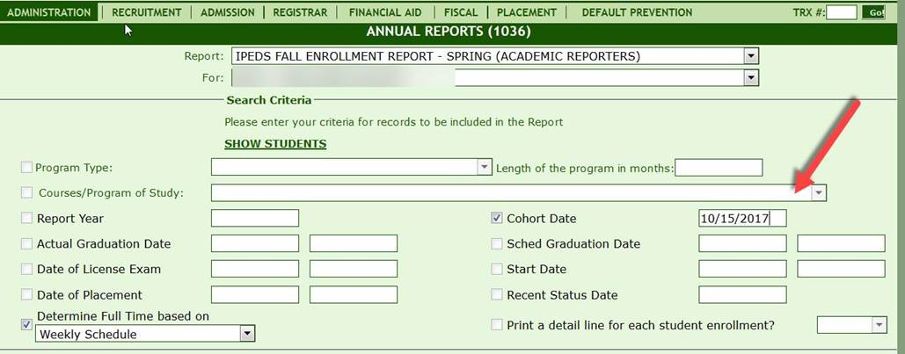

* **Remember to save or print your reports for back-up. All blue areas are hyperlinks, click to view student lists.**

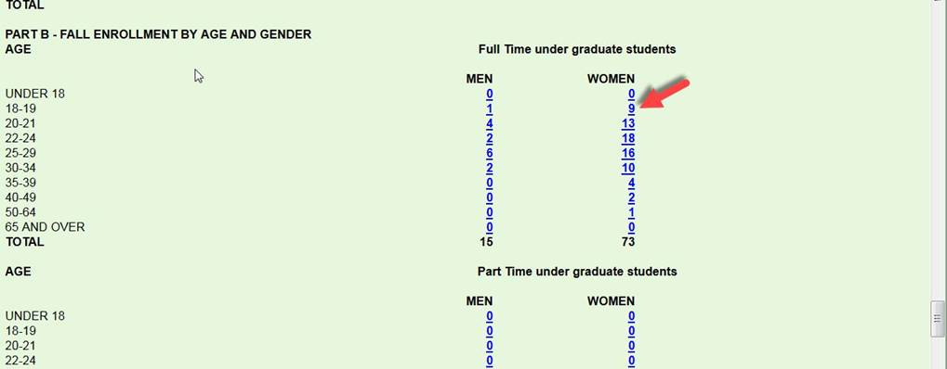

**Rafael Gonzalez**

**President**

**R. Gonzalez Management, Inc.**

**3560 S. La Cienega Blvd. Ste. G**

**Los Angeles,  CA 90016**

**(323)730-8700 ext. 239**

**(323)730-8701 fax**