**R. Gonzalez Management Inc. (RGM)**

Student Financial Aid Services Phone No. (323) 730-8700

3560 S. La Cienega Blvd. Suite G Fax No. (323) 730-8701

Los Angeles, CA 90016-4400 Web Page <http://www.rgmsms.com>

**RGM Memo**

Date: June 5, 2018

To: Dear School Owners and Financial Aid Personnel,

RE: Refreshing your browser

Dear School Owners and Financial Aid Personnel,

RGM MEMO JUNE 5, 2018

If you are having issues with the RGM time clock, use the instructions on the attachment to refresh your browser. If you are not having issues you may use the instructions for any future issues. If you have any questions please contact Arc Vasquez at [arc_vasquez@rgmsms.com](mailto:arc_vasquez@rgmsms.com) or at (323) 730-8700 ext. 206.

**How to clear cache in Mozilla Firefox**

<https://support.mozilla.org/en-US/kb/how-clear-firefox-cache>

1. Click the menu button New Fx Menuand choose **Options**.
2. Select the **Advanced** panel.
3. Click on the **Network** tab.
4. In the **Cached Web Content** section as shown in Fig.1, click **Clear Now**.

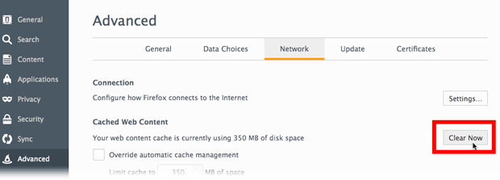

Fig.1

1. Close the ***about:preferences*** page. Any changes you've made will automatically be saved.

# Automatically clear the cache

You can set Firefox to automatically clear the cache when Firefox closes:

1. Click the menu button New Fx Menuand choose **Options**.
2. Select the **Privacy** panel.
3. In the **History** section, set **Firefox will:** to **Use custom settings for history**.
4. Select the check box for **Clear history when Firefox closes**, as shown in Fig.2.

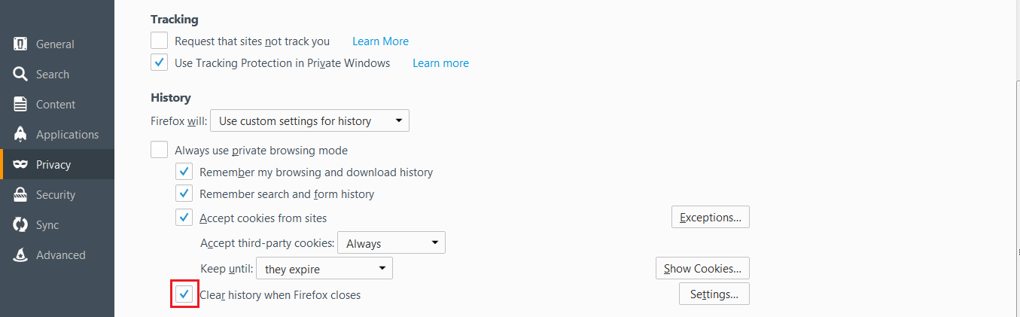

Fig. 2

1. Beside **Clear history when Firefox closes**, click the **Settings**… button. The **Settings for Clearing History** window will open as shown in Fig.3.
2. In the **Settings for Clearing History** window, put a check mark next to **Cache**.

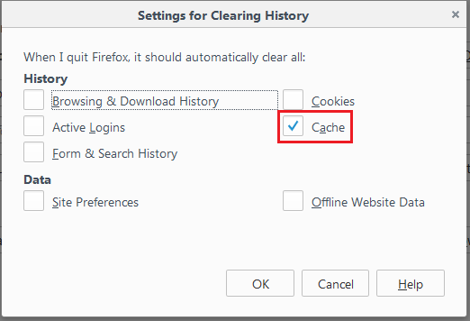

Fig. 3

1. Click **OK** to close the *Settings for Clearing History* window.
2. Close the **about:preferences** page. Any changes you've made will automatically be saved.

**How to clear cache in Google Chrome**

Cookies are files created by websites you’ve visited, and together with your browser’s cache, help pages load faster, but there are times that these data can be corrupted and clearing them is a quick way to resolve seemingly odd behavior in your browser.

Clearing your browser’s cache and cookies means that website settings (like usernames and passwords) will be deleted and some sites might appear to be a little slower because all of the images have to be loaded again.

1. On your computer, open Chrome.
2. Click the icon with **3 dots** at the top right hand corner of the browser as shown in Fig. 1

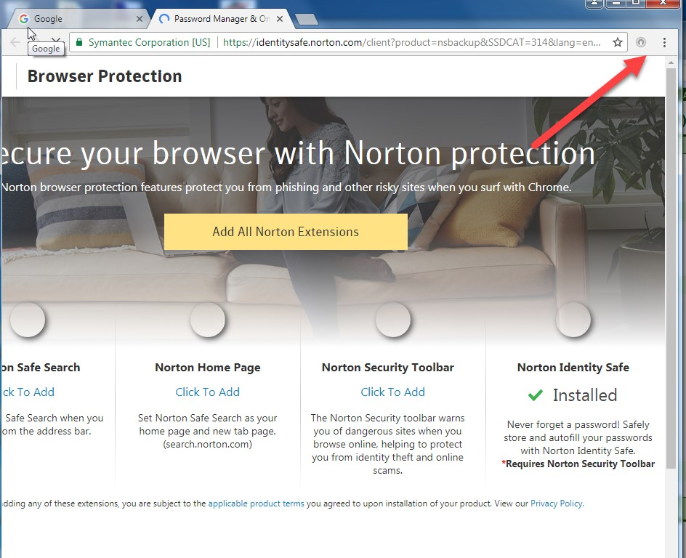

Fig.1

1. Click the “**Settings**” button on the drop down list as shown in Fig. 2

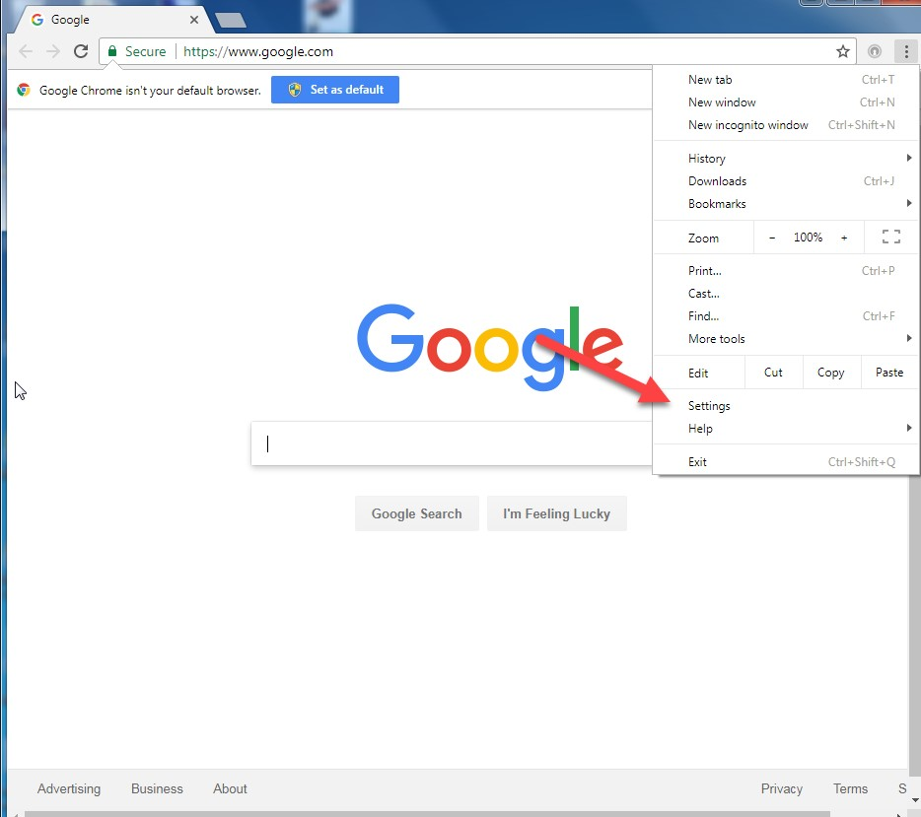

Fig.2

1. Click the **Down Arrow**, next to **Advanced** button on the bottom part of the browser as shown in Fig 3.

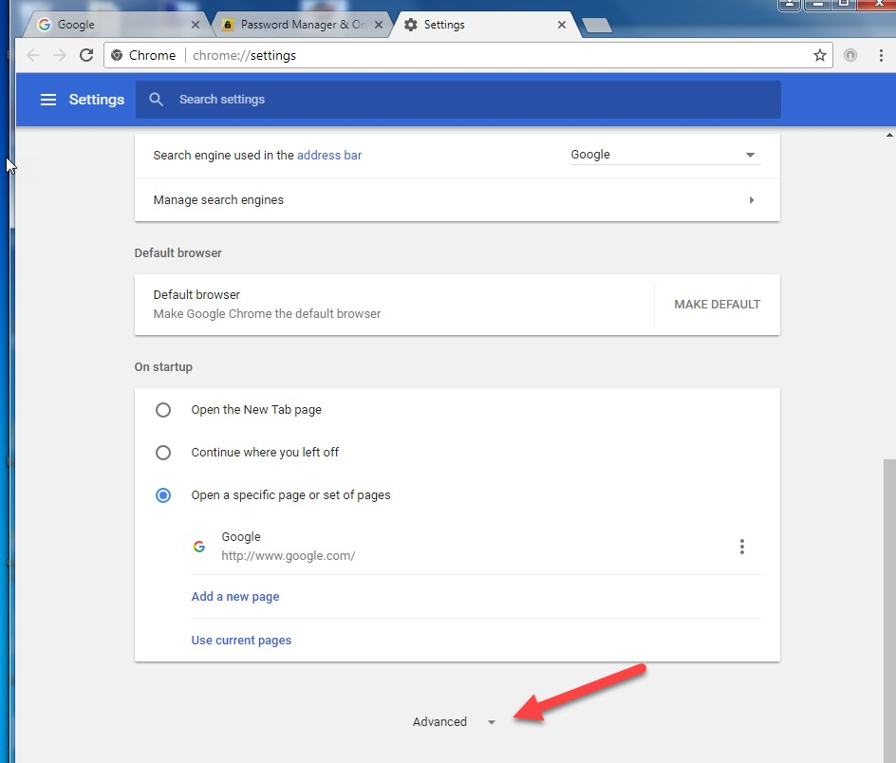

Fig. 3

1. Click the **Right Arrow** next to **Clear browsing data** as shown in Fig. 4.

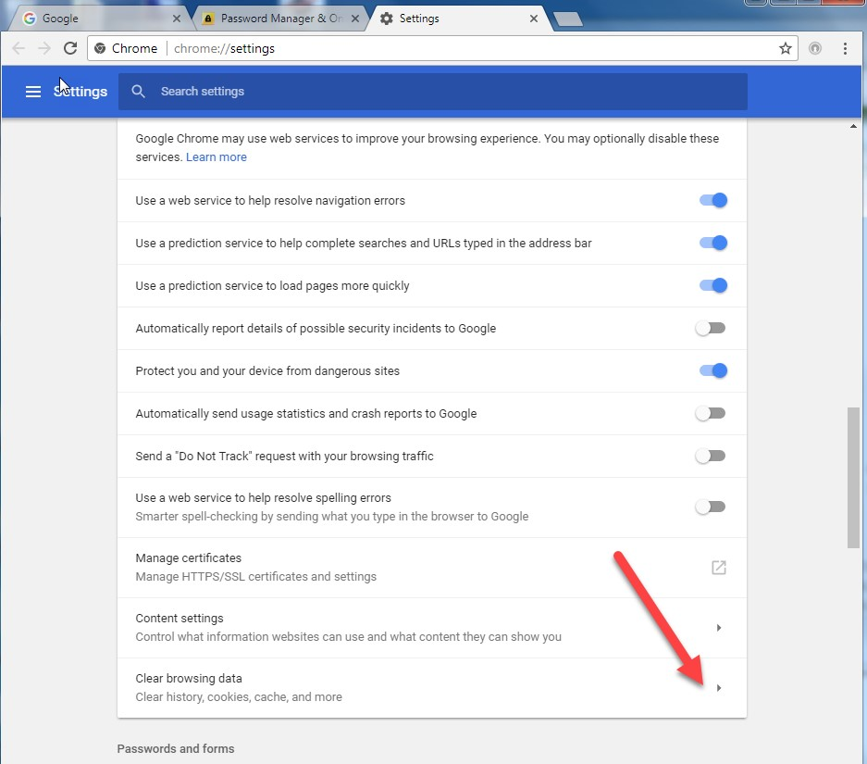

Fig. 4

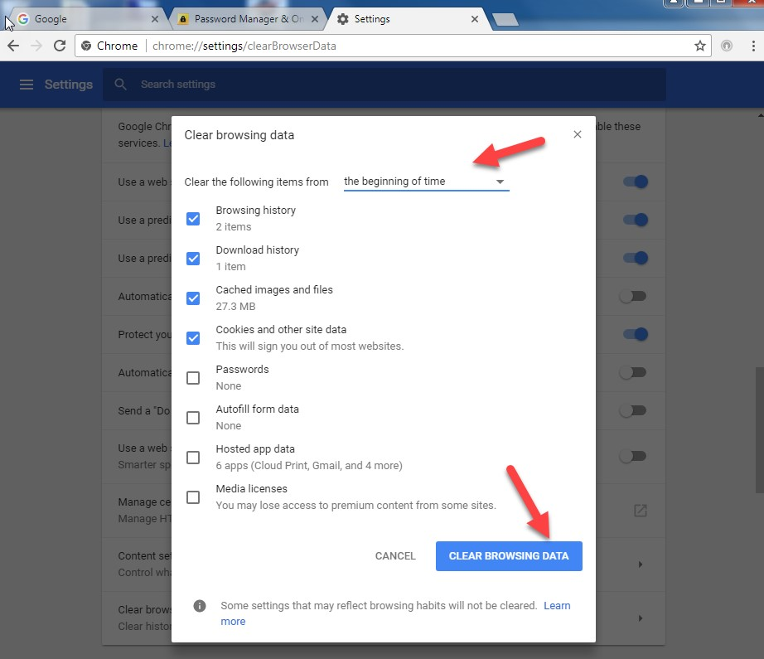

Fig. 5

1. Use the menu at the top, to select the amount of data that you want to delete. Choose **beginning of time** to delete everything.
2. Then click the **Clear Browsing Data**.
3. Close and re-open the browser to effect change.