R. Gonzalez Management Inc. (RGM)
Student Financial Aid Services Phone No. (323) 730-8700
3560 S. La Cienega Blvd. Suite G Fax No. (323) 730-8701
Los Angeles, CA 90016-4400 Web Page http://www.rgmsms.com
RGM Memo
Date: June 15, 2018
To: Dear School Owners and Financial Aid Personnel,
RE: IRS Data Retrieval tool
This is a reminder on an Electronic Announcement was posted on August 7, 2017, informing us of changes to the IRS Data Retrieval Tool process for the 2018-2019 FAFSA form. Below we have a few samples on the codes comparing with an ISIR.

This sample is for a dependent student: You need the IRS transcripts for both student and parent.
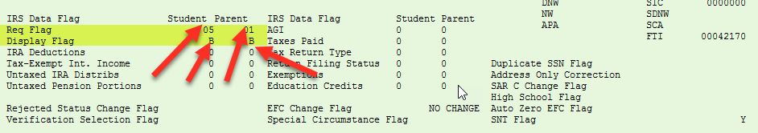
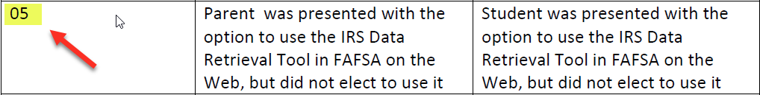
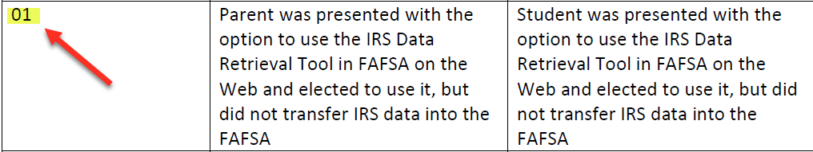

This Sample is for an independent student: You do not need the IRS Transcripts.
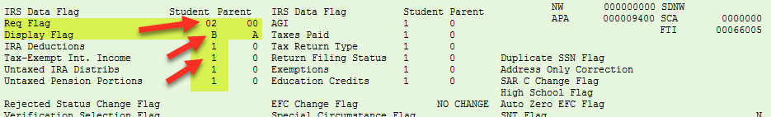
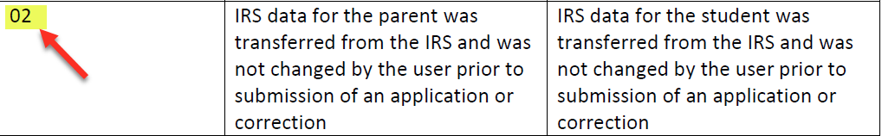
This Sample is for a dependent student who did not file: You do not need the IRS Transcripts for the parent or a verification of a non-tax filer for the student.
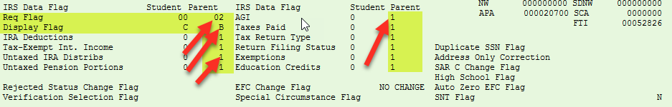

This sample is for a dependent student who did not file neither did the parents. You will need the verification of non-tax filer for the parent but not for the student.
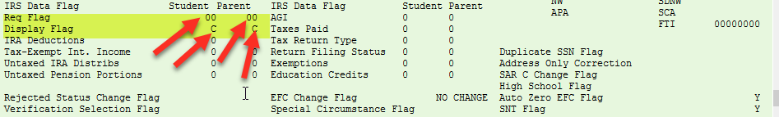
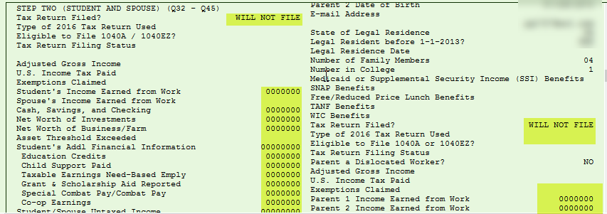
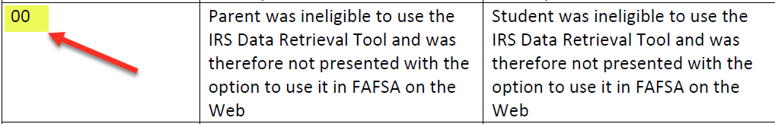

This sample is for an independent student that did not file taxes. This student needs verification of non-tax filer.
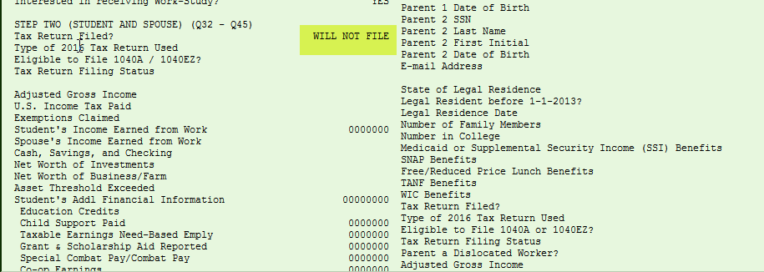

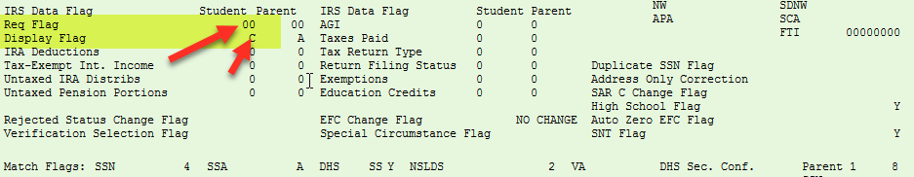
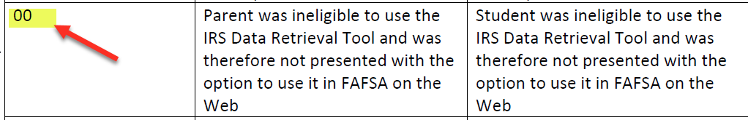

This sample is for an independent student that did an amended tax return. Please see below on what you are required to have.
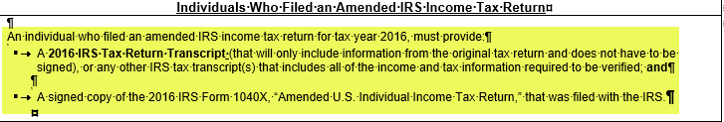
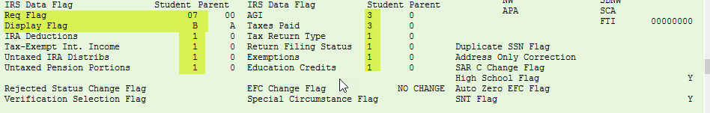

The codes below are the IRS Data field Flags:
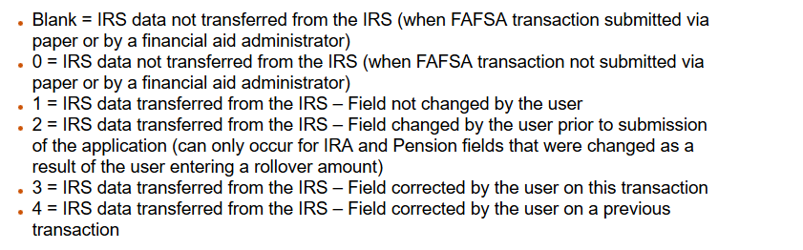
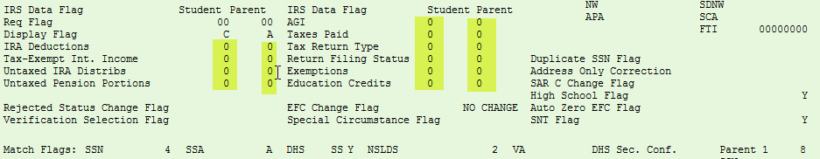
Please remember this is only for students who are selected for Verification Tracking flags 1 and 5. You can find the Verification Tracking flag group on page #3.
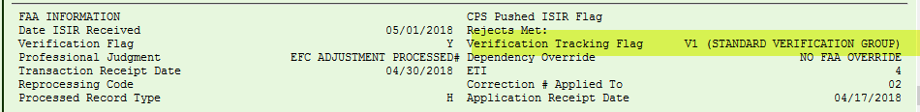
The only code you do not need an IRS Transcript is 02, any other code you will need to provide them.

If you have any questions, please contact us.

