**R. Gonzalez Management Inc. (RGM)**

Student Financial Aid Services Phone No. (323) 730-8700

3560 S. La Cienega Blvd. Suite G Fax No. (323) 730-8701

Los Angeles, CA 90016-4400 Web Page <http://www.rgmsms.com>

**RGM Memo**

Date: June 28, 2018

To: Dear School Owners and Financial Aid Personnel,

RE: 2019 FSEOG and FWS allocations

Dear School Administrators,

RGM MEMO JUNE 28, 2018

The 2018-2019 FSEOG and FWS Allocations have been posted in the RGM System. If you school requested funding for these programs you can check your Allocation by going to the following screen TRX# 5604 and entering the criteria shown below:

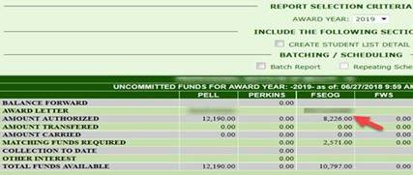

The Federal Share amount allocated is the total under FSEOG/FWS Amount Authorized. On the same screen you can check the schools Institutional Match amount requirement. If you have any questions feel free to contact Lidia Swoopes at  [lidia_swoopes@rgmsms.com](mailto:lidia_swoopes@rgmsms.com) or at (323)730-8700 ext.245.