**R. Gonzalez Management Inc. (RGM)**

Student Financial Aid Services Phone No. (323) 730-8700

3560 S. La Cienega Blvd. Suite G Fax No. (323) 730-8701

Los Angeles, CA 90016-4400 Web Page <http://www.rgmsms.com>

**RGM Memo**

Date: July 19, 2018

To: Dear School Owners and Financial Aid Personnel,

RE: FSA E-Training

Dear School Owners and Financial Aid Personnel,

RGM MEMO JULY 19, 2018

This email is to inform you that the FSA Training website just released four new learning tracks. We list the learning tracks below along with the link and the steps for how to get to them. We recommend that you watch them all, especially Pell LEU and Unusual Enrollment.

Please copy and paste link to your browser:

<https://fsatraining.info/index.php?redirect=0>

1. **PELL LEU and Unusual Enrollment History (UEH)**

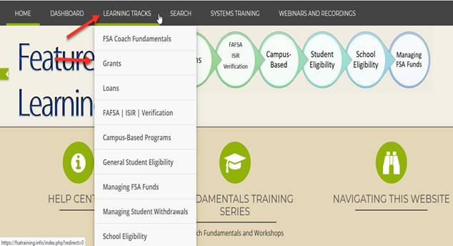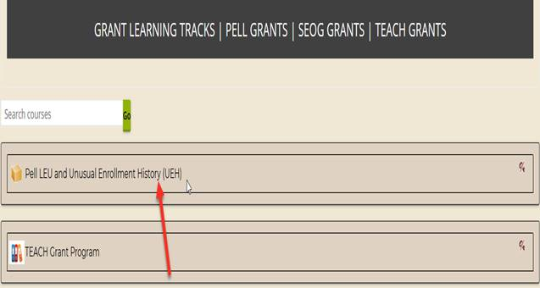

1. **R2T4 for Credit Hour Programs**
2. **R2T4 for Clock-Hour Programs**
3. **R2T4 for Programs offered in modules**

