R. Gonzalez Management, Inc. (RGM)
Student Financial Aid Services Phone No. (323) 730-8700
3560 S. La Cienega Blvd., Suite G Fax No. (323) 730-8701
Los Angeles, CA 90016-4400 Web Page http://www.rgmsms.com
RGM MEMO

DATE: August 28, 2018
TO: School Owners and Financial Aid Personnel
RE: 2018 GE Reporting Due October 1, 2018
___________________________________________________________________

We will soon be processing GE Reporting for award year 2017-2018, which has a deadline of October 1, 2018.

2018 Award Year GE Reporting must be ACCEPTED by October 1, 2018. We will follow the same process as before by having your school administrator send us a form specifying whether we are to send the 2018 award year GE data for your school.

We will start sending 2018 data for your school in early September if you have sent us the form authorizing us to do so.
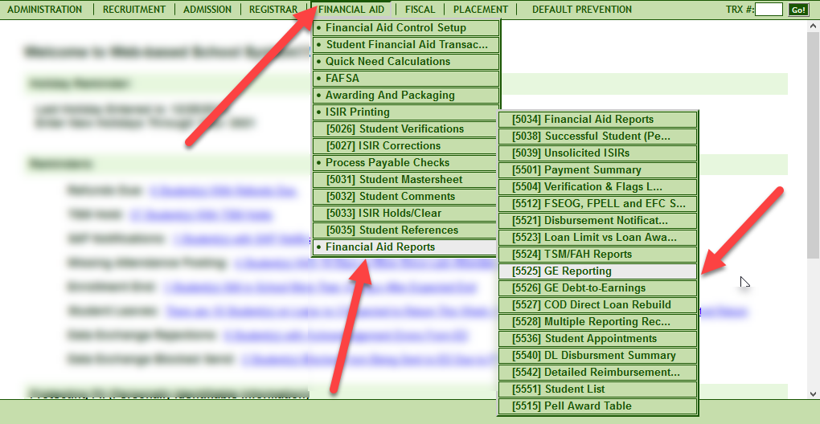

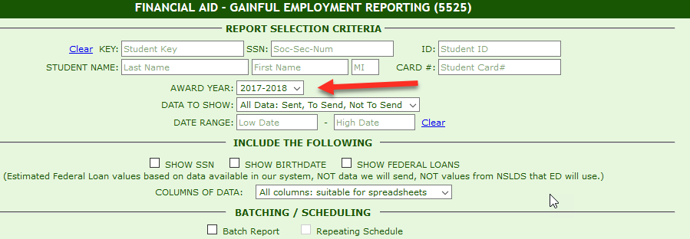
Sending the information one month prior to the October 1, 2018 acceptance deadline will give schools time to correct any errors that may come in from NSLDS.

It is important that you review any information on the report, especially your Institutional Debt, and work on the 2018 data as soon as possible.

Please return this form for 2018 award year GE Reporting as soon as possible to:

Mayra Grijalva at mayra_grijalva@rgmsms.com or
Johanna Gonzalez johanna_gonzalez@rgmsms.com.

Once the form is received, the controls in the system will be opened to send the data for your school.

Thank you,
Rafael

Name of Institution______________________________________________

RGM School or Campus Number ___________________________________

Name, Title and Signature of Person submitting this form__________________________________________________________

I authorize RGM to submit Gainful Employment data via batch reporting for the 2018 award year which has an acceptance deadline of October 1, 2018.

Yes ______________

No ______________

Thank you.

