**R. Gonzalez Management, Inc. (RGM)**

Student Financial Aid Services Phone No. (323) 730-8700

3560 S. La Cienega Blvd., Suite G Fax No. (323) 730-8701

Los Angeles, CA 90016-4400 Web Page <http://www.rgmsms.com>

**RGM MEMO**

DATE: August 30, 2018

TO: School Owners and Financial Aid Personnel

RE: Title IV credit balance

___________________________________________________________________

Dear School Owners and Financial Aid Personnel:

RGM MEMO August 30, 2018

In the past we have sent various emails regarding credit balances and had accommodated our system to work around this matter. However, we continue to encounter grave situations in ED program reviews and annual CPA audits.

Let me take this opportunity to describe how to prevent problems and correctly proceed on this topic.

A credit balance will be generated by the manner the FSA is packaged to students:

Academic year is defined as

  900 clock hours in a minimum period of 26 instructional weeks or

  24 semester/trimester credit hours in a minimum period of 30 instructional weeks or

  36 quarter credit hours in a minimum period of 30 weeks.

A second academic year will be for the subsequent equal period of enrollment or less.

A third academic year will be after a second year is concluded.

Please remember that an instructional week is a period of seven consecutive calendar days in which a class or exam will be scheduled on at least one of those days.

FSA funds are to be disbursed in accordance to your payment periods in your academic year:

Clock hours 450 and 450 = 900 completed hours

Semester/trimester credit hours 12 and 12 = 24   (**NOT CLOCK HOURS**)

Quarter credit hours 18 and 18 = 36 (non-term school)    (**NOT CLOCK HOURS**)

ALL payment periods must be documented at the school and posted in the RGM system as hours and instructional weeks are earned, with the appropriate and documented grades.

Back to packaging, any aid awards from Title IV that exceed 50% of the cost of attendance for a first payment period in an academic year, will at the time of disbursement represent a **Title IV credit balance and be due to the student as soon as possible but no later than 14 calendar days from the disbursement date.**

Any time you are crediting the student account with Title IV funds that create a negative balance (payment period charges less total title IV applied = a negative balance), that amount must be paid to the student or the parent if PLUS loan, UNLESS you are at the end of the first payment period in any academic year and the student or parent provides written authorization to the school to retain those funds for the second payment period in the same academic year. If so, please see our attached form, it is also available in the RGM system for you to generate along with a posting you may use for tracking and for the funds to stay under the school and not move to the student. The credit balance form was recently revised. We’ve highlighted the sections we revised on the screenshot below. Please replace the form  you have with the one attached. Below are the steps on how to generate the form and how to post the hold for you to keep track.  **Please keep in mind that Schools on the HCM1, HCM2 and reimbursement payment methods are prohibited from holding credit balances.** Schools on HCM1, HCM2 and Reimbursement payment methods must credit a student’s ledger account for Title IV funds the student or parent is eligible to receive and pay the amount of any credit balance due before the school submits a request for those funds. A requirement to pay students their credit balances prohibits schools from holding the funds. Obtaining an authorization is also prohibited.

Two more notes to remember:

At the end of any academic year, all Title IV credit balances must be paid to the student or parent.  A credit balance at this time cannot be carried into the following academic year.

Institutional charges incurred in an academic year cannot be carried into the next academic year if more than $200.

We would also like to remind you of our credit balance report under Fiscal, Fiscal Reports, [6516] Title IV Credit Balance. Please see the screenshots below on how to generate the credit balance report. Under Fiscal, Student Fiscal Transactions [6014] School Paid to Students you can post the payment made to the student. Under Kind of Aid the school needs to select the “Type of Aid” where the amount being given to the student is coming from. (Example: Pell, Sub, Unsub, PLUS, etc.). This is very important because if it is not reported correctly, the school’s 90-10 amounts can be incorrect. See below for instructions. For more information on Credit Balances, please read the FSA handbook 2017-2018 Volume 4- Processing Aid and Managing FSA Funds and Volume 5- Withdrawals and the Return of Title IV funds, the links are provided below.

Credit Balance Form:

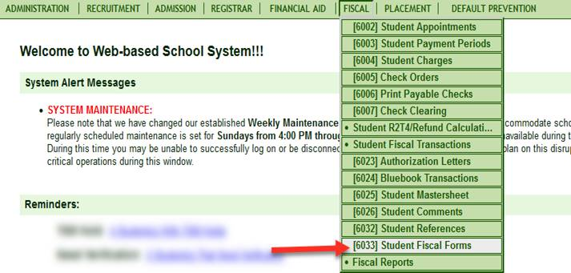

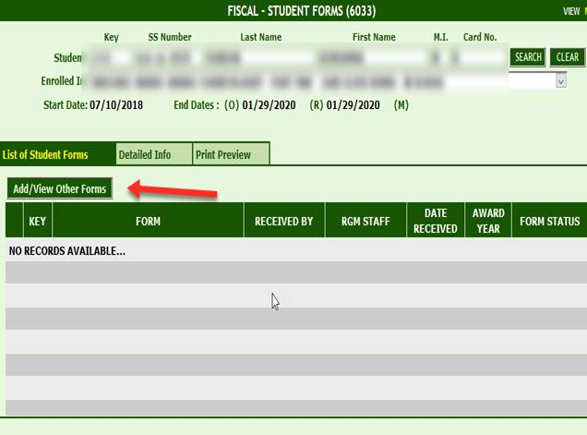

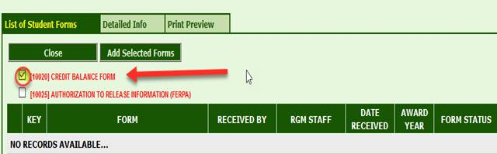

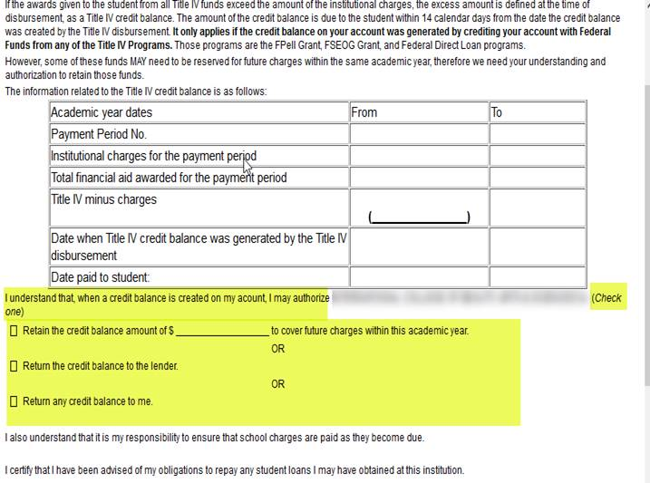

Credit Balance Report:

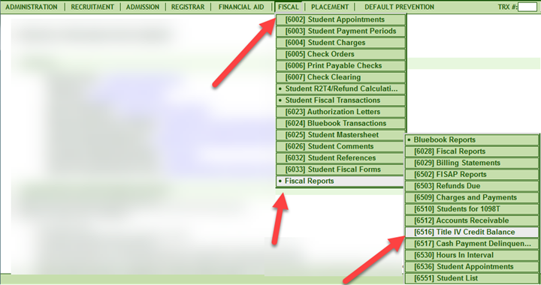

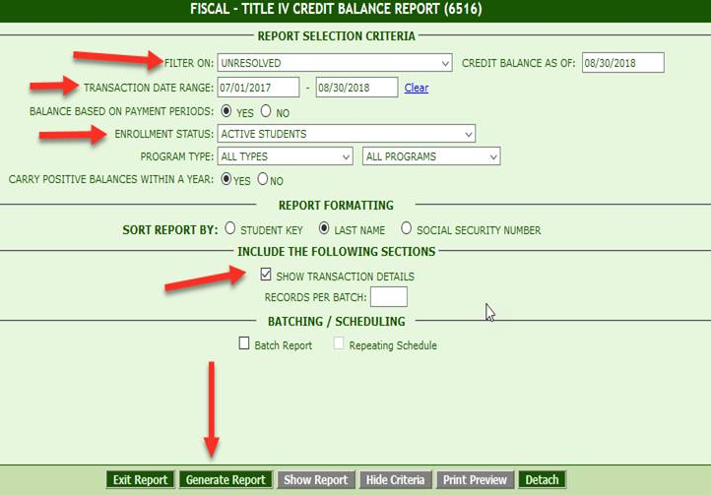

School Paid to Student:

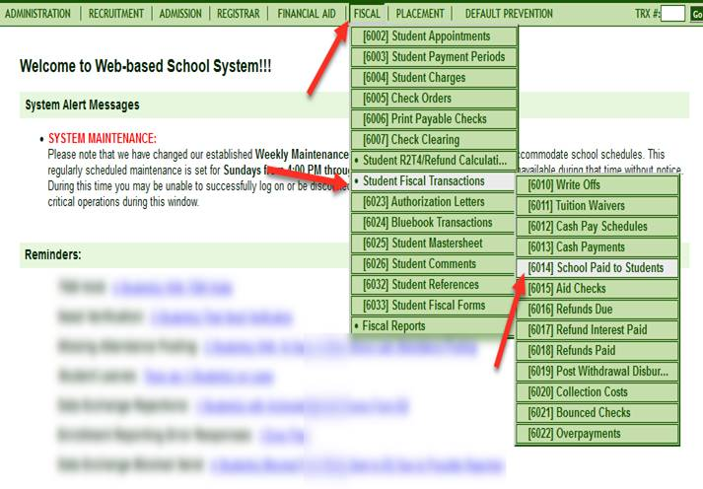

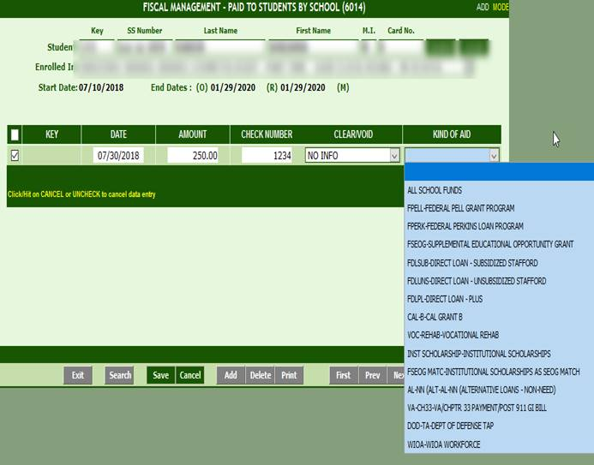

Please copy and paste link to your browser:

[Volume 4 - Processing Aid and Managing FSA Funds](https://ifap.ed.gov/fsahandbook/1718FSAHbkVol4.html)

[Volume 5 - Withdrawals and the Return of Title IV Funds](https://ifap.ed.gov/fsahandbook/1718FSAHbkVol5.html)