**R. Gonzalez Management, Inc. (RGM)**

Student Financial Aid Services Phone No. (323) 730-8700

3560 S. La Cienega Blvd., Suite G Fax No. (323) 730-8701

Los Angeles, CA 90016-4400 Web Page <http://www.rgmsms.com>

**RGM MEMO**

DATE: August 30, 2018

TO: School Owners and Financial Aid Personnel

RE: Update on Award letter

___________________________________________________________________

Dear School Owners and Financial Aid Personnel:

RGM MEMO August 30, 2018

This email is to notify you that we have made some changes to the Award Letter. Please see the changes below.

**This part used to have one award year, depending on what award year the student began and that you packaged them on. It has been removed.**

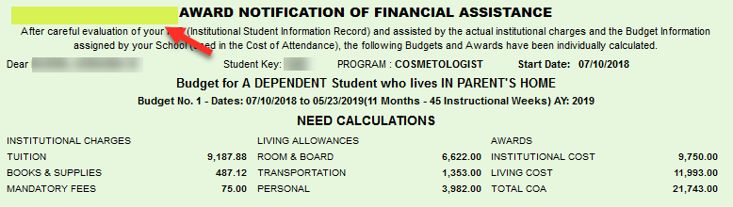

**We added to the budgets that have two award years, both award years, not just the first one.**

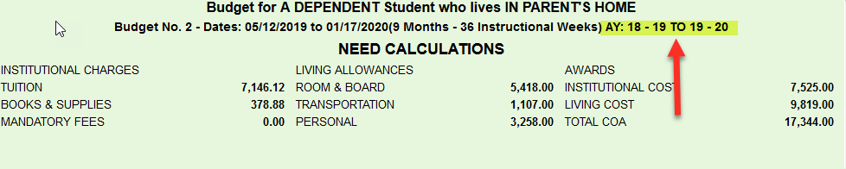

**We also added the EFC to be included for both award years. Example: If the student has a zero EFC for one award year and not the other one or zero on both or just a different EFC on both award years, the award letter is now showing the award year it belongs to.**

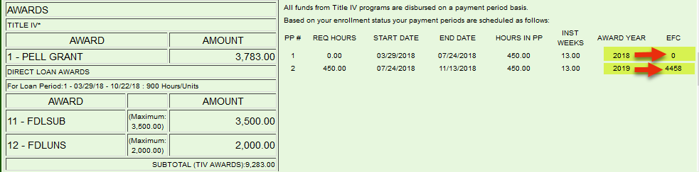

**We also added the word “Required” next to student’s initials on item #7, if the student decides to borrow less or no loan amount that they’re eligible for, they are required to initial this section.**

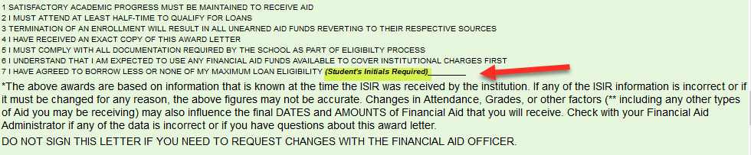

**It is very important that the student initials (if applicable), signs and dates the award letter.**

If you have any questions, please contact us.