R. Gonzalez Management, Inc. (RGM)
Student Financial Aid Services Phone No. (323) 730-8700
3560 S. La Cienega Blvd., Suite G Fax No. (323) 730-8701
Los Angeles, CA 90016-4400 Web Page http://www.rgmsms.com
RGM MEMO

DATE: September 04, 2018
TO: School Owners and Financial Aid Personnel
RE: New Mastersheet Layout
___________________________________________________________________
Dear School Owners and Financial Aid Personnel,

RGM MEMO SEPTEMBER 4, 2018

On August 20, 2018, we sent an email notifying you of the changes that we were making on the layout of the Mastersheet. We’ve added a couple of new items that will be beneficial for you the schools. We know you are all used to the Mastersheet the way it has been for years, we know it might take some time to get used to it, but it is very well-ordered and broken down in sections that are more practical to use. These changes will be effective September 10, 2018. We have attached a description of the new features available with the new Mastersheet. Please do let us know if you have any questions or comments, and we will gladly answer them.

Changes to the Mastersheet on September 10th, 2018
Default Selection: The new Mastersheet will no longer feature the option to check all sections of the report. Rather, there will be a “Check Default” option, which would select the more pertinent selections.
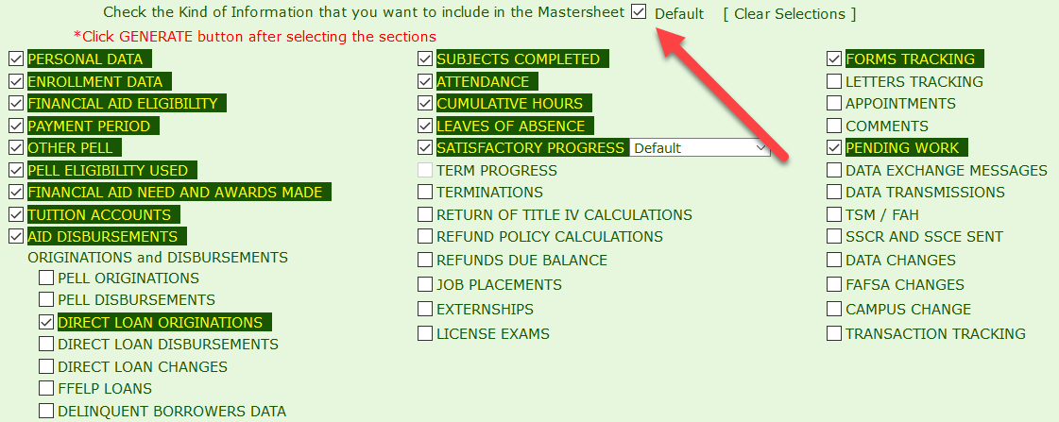
Detach: The Mastersheet has a new “Detach” button, which will display the report on a new, separate window from the RGM system. The report can be detached without clicking Generate first.
Suppressed sections: The Mastersheet will be generated and displayed in clear, separate sections. When generated on the main screen of the system, the sections will be expanded, displaying all data/records selected, with the exception of the Personal Data section.
When the Mastersheet is detached, the selected sections will display collapsed. The user will be able to see the sections, but not the data in them. Each section can be expanded to view data by clicking on the individual section, or by clicking on the Expand button. The Expand button will open all sections, again, except for the Personal Data section. The Personal Data will always have to be expanded manually, to protect the student’s personal information.
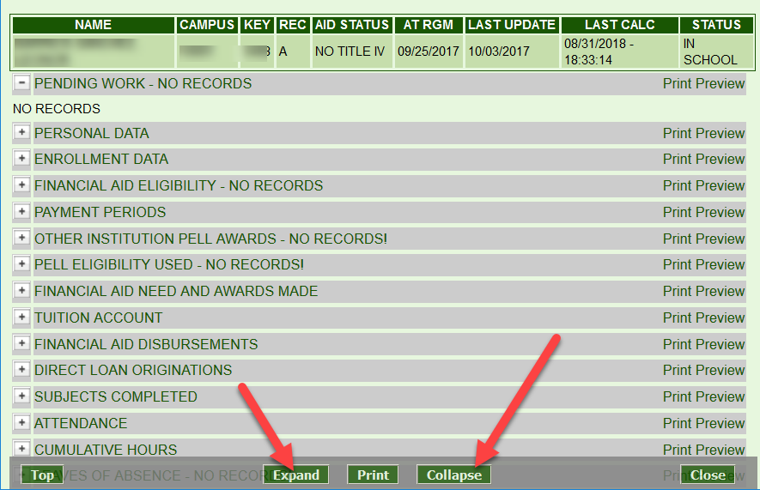
Print preview: Each section has an individual Print Preview option where a separate window will open and display the selected section. When in the Print Preview screen, the section will highlight with a click, and that individual report can be copied and pasted to an Excel sheet.
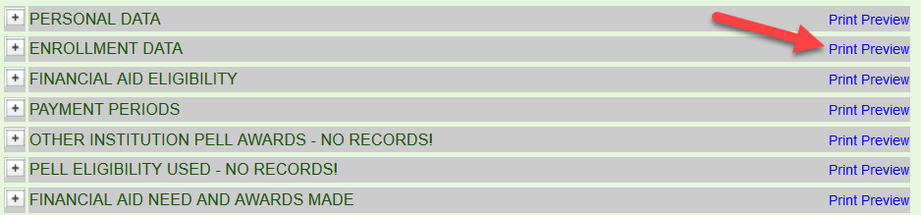
There is no print preview screen for the whole Mastersheet, but the whole report can be printed from the original screen or the detached window.
Archive: The Archive button allows users to save generated Mastersheets. The reports are saved indefinitely and have the data current to the time of the save (old data will be shown on old Mastersheets).
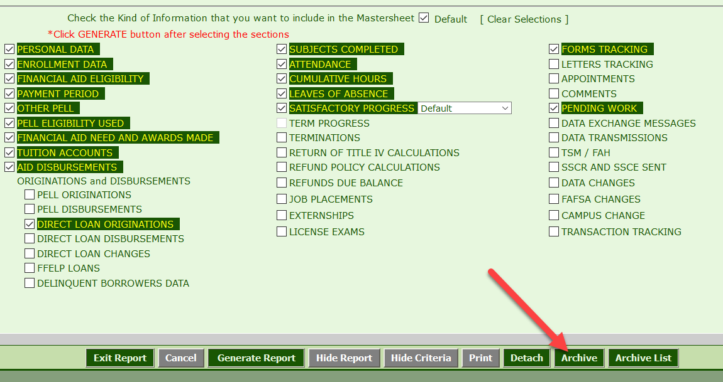
Archive List: The Archive List will display the list of all Mastersheets archived by all users for the selected student. The list will display the User ID that archived each report, the date and the time they were archived, and the sections that are shown on that report. When the cursor is hovered over a report on the list, the sections selected on that Mastersheet will be highlighted on the bottom of the window. When selected, the generated report will appear in a detached window.
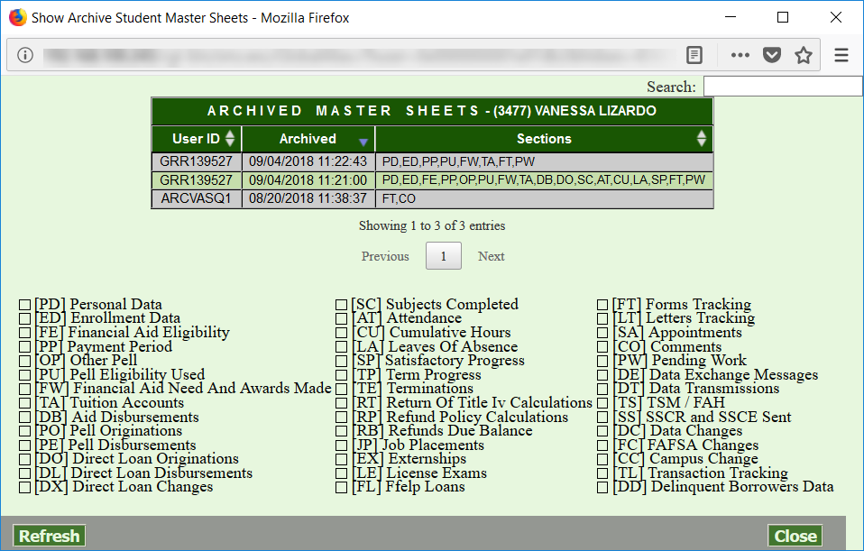
Links to Archive: The archived Mastersheets can also be shared with others without access to the RGM system. Selecting a Mastersheet from the Archive List will prompt a new window to open. The link on the address bar of the new window can be copied and shared. Outside users can then view the Mastersheet by following that link. Caution: Access to the RGM system is protected when sharing a Mastersheet, but the student’s SSN can still appear under the Personal Data tab. Exercise caution when sharing this report.
SSN Security: The Social Security Numbers of students will now only be fully displayed in the Personal Data section of the Mastersheet. Anywhere else where the SSN is displayed, the number will be replaced by #SSN#. If a SSN in an ID does NOT match the student SSN in Personal Data, that SSN will be displayed.
PII Security: In addition to requiring an explicit click to see the Personal Data section on screen, a check box must also be clicked to allow the PPI in that section to print.

