R. Gonzalez Management, Inc. (RGM)
Student Financial Aid Services Phone No. (323) 730-8700
3560 S. La Cienega Blvd., Suite G Fax No. (323) 730-8701
Los Angeles, CA 90016-4400 Web Page http://www.rgmsms.com
RGM MEMO

DATE: September 11, 2018
TO: School Owners and Financial Aid Personnel
RE: Printing the Mastersheet
___________________________________________________________________
Dear School Owners and Financial Aid Personnel,

RGM MEMO SEPTEMBER 11, 2018

The new Mastersheet was released on September 10, 2018. We wanted to send this email to make sure you are aware of how to print the Mastersheet. It is the same process as before, the only difference is that the Personal Data drop down will not show unless you hit the + icon. The Personal Data display option was disabled to protect student’s personal information. If you want to print that part of the Mastersheet, you will need to check the box as instructed on the previous email. The recommended printing settings for the Mastersheet will generate once you click the word print, but you may use the settings that work best with your browser. The Mastersheet will only print with the items defaulted or selected by you before you generate it. Please see the attachment for more details. If you have any questions, please contact us.

Printing the Mastersheet
Default Selection: The new Mastersheet will no longer feature the option to check all sections of the report. Rather, there will be a “Check Default” option, which would select the more pertinent selections. You may check and uncheck any box as needed.
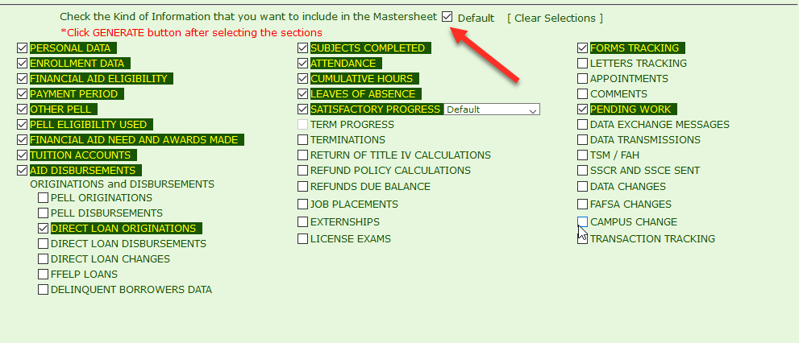

Once you select the items, you click Generate Report:
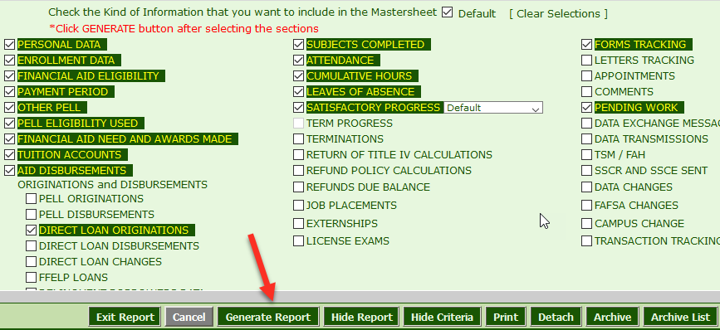
To show Personal Data, click the + icon:
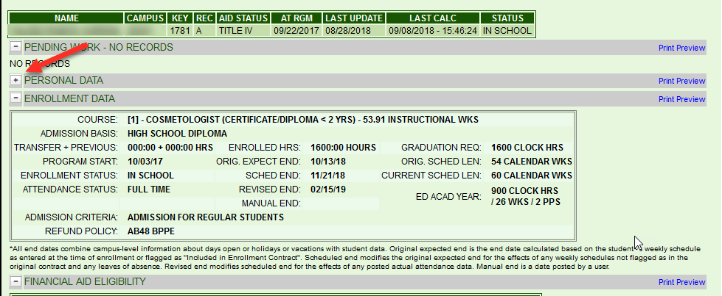

To be able to print Personal Data on the Mastersheet, check the box that says Print PII:
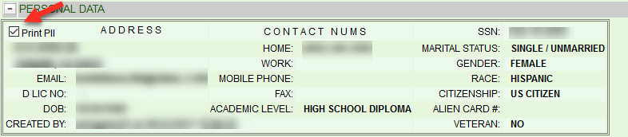
When you are ready to print, just click print:
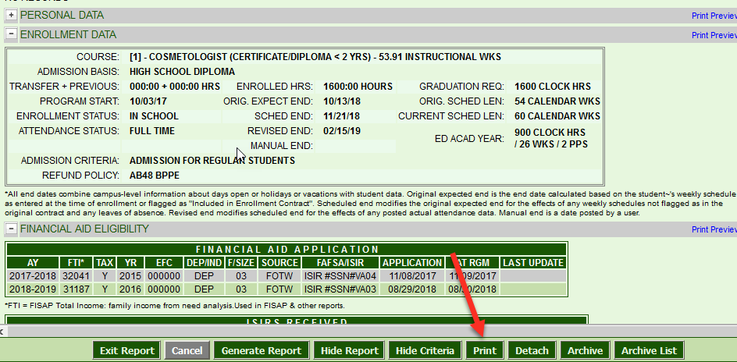
You will get this screen with the recommended printer settings, but you may use the settings that work best with your browser. If you fixed the settings and you are ready to print, click Print Mastersheet:

