**R. Gonzalez Management, Inc. (RGM)**

Student Financial Aid Services Phone No. (323) 730-8700

3560 S. La Cienega Blvd., Suite G Fax No. (323) 730-8701

Los Angeles, CA 90016-4400 Web Page <http://www.rgmsms.com>

**RGM MEMO**

DATE: September 13, 2018

TO: School Owners and Financial Aid Personnel

RE: Campus Safety and Security Reporting Deadline

___________________________________________________________________

Dear School Owners and Financial Aid Personnel,

RGM MEMO SEPTEMBER 13, 2018

This is a reminder email on the Campus Safety and Security Reporting for the years **2015, 2016,** and **2017**. The school is responsible to disclose on the school’s website and distribute the annual security report by **October 1st**.This is a firm deadline. There are no grace periods and there are no exceptions. Please keep in mind that the school is also responsible to maintain a log of incidents. We have created a log of incidents that you may use if you would like to, but you are not required to use. Also, please make sure that the Information for the Institutional official, who is in charge to report incidents, is up to date. If you need to verify or update the form, it is at the bottom of the last page of the Campus Safety Act disclosure form attached. We included a screenshot below. We would like to remind you that the forms are available in the RGM website, under the clients-only tab. We have also attached a copy of the forms. Below we include a link to the Handbook for Campus Safety and Security Reporting. The Handbook has details about the log and any other questions you may have.

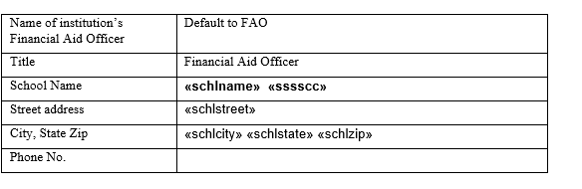

Please copy and paste link to your browser:

<https://ifap.ed.gov/eannouncements/attachments/HandbookforCampusSafetyandSecurityReporting.pdf>